Automated Road Damage Detection Using UAV Images and Deep Learning Techniques

INTRODUCTION
Managing the maintenance of all the roads in a country is essential to its economic development. A periodic assessment of the condition of roads is necessary to ensure their longevity and safety. Traditionally, state or private agencies have carried out this process manually, who use vehicles equipped with various sensors to detect road damage. However, this method can be time-consuming, expensive, and dangerous for human operators. To address these challenges, researchers and engineers have turned to Unmanned Aerial Vehicles (UAVs) and Artificial Intelligence (AI) technologies to automate the pro The associate editor coordinating the review of this manuscript and approving it for publication was Halil Ersin Soken . cess of road damage detection. In recent years, there has been a surge of interest in using UAVs and deep learning-based methods to develop efficient and cost-effective approaches for road damage detection. Unmanned aerial vehicles have proven to be versatile in various applications, including urban inspections of objects and environments. They have been increasingly used for road inspections, offering several advantages over traditional methods. These vehicles are equipped with high-resolution cameras and other sensors that can capture images of the road surface from multiple angles and heights, providing a comprehensive view of the condition of the road. Additionally, UAVs can cover a large area relatively quickly, reducing the need for manual inspections, which can be dangerous for human operators. As a result, the use of UAVs for road inspections has gained significant attention from researchers and engineers. Combining UAVs with artificial intelligence techniques, such as deep learning, can develop efficient and cost-effective approaches for road damage detection. It is frequently mentioned as being utilized for urban inspections of things like swimming pools rooftops vegetation and urban environments. Currently, road condition inspections in Spain are performed manually, requiring personnel to travel along roads to identify damage points. This method incurs high costs due to the need for human labor and specific cameras and sensors for the task. The decision-making process for repairing road damages is the responsibility of an expert. In contrast, countries like China have a vast network of roads and highways, making them susceptible to surface cracks and rainwater infiltration, which can accelerate the deterioration of roads and pose risks to vehicle safety. Without timely detection and the rapid availability of information on road defects, excessive wear on vehicles and an increased likelihood of traffic accidents can occur, leading to further financial losses. Therefore, the development of automated techniques for detecting road deterioration has become a critical area of research, with many universities and research centers collaborating to find effective solutions. Automatic road damage detection is an active area of research that aims to detect and map various types of road damage using multiple techniques such as vibration sensors, Light Detection And Ranging (LiDAR) sensors and image-based methods. These techniques are often used in combination to improve the accuracy of damage detection. Machine learning approaches, such as deep learning, are commonly used in image-based techniques to recognize various types of road degradation. These methods typically require a dataset of images, which can include top-down photographs, images captured by unmanned aerial vehicles pictures obtained by mobile devices images obtained from satellite image platforms thermal images and 3D images or stereo vision of the asphalt surface. Researchers have been conducting studies using a variety of datasets to train the model, incorporating additional images captured by drones, cameras mounted on cars, and satellites. To facilitate the learning process, these datasets are often annotated to identify different types of road damage, including, but not limited to potholes, cracks, and rutting. Annotating these images enables the algorithm to learn to detect and classify various types of road damage accurately. Using a large and diverse dataset, researchers can enhance the accuracy and reliability of their models, ensuring that they can effectively identify and address different types of damage on the roads.
1.1 Objective of the project:
This paper presents a novel automated road damage detection approach using Unmanned Aerial Vehicle (UAV) images and deep learning techniques. Maintaining road infrastructure is critical for ensuring a safe and sustainable transportation system. However, the manual collection of road damage data can be labor-intensive and unsafe for humans. Therefore, we propose using UAVs and Artificial Intelligence (AI) technologies to improve road damage detection’s efficiency and accuracy significantly. Our proposed approach utilizes three algorithms, YOLOv4, YOLOv5, and YOLOv7, for object detection and localization in UAV images. We trained and tested these algorithms using a combination of the RDD2022 dataset from China and a Spanish road dataset. The experimental results demonstrate that our approach is efficient and achieves 59.9% mean average precision mAP@.5 for the YOLOv5 version, 65.70% mAP@.5 for a YOLOv5 model with a Transformer Prediction Head, and 73.20% mAP@.5 for the YOLOv7 version. These results demonstrate the potential of using UAVs and deep learning for automated road damage detection and pave the way for future research in this field.
2. LITERATURE SURVEY:
‘‘A platform for swimming pool detection and legal verification using a multi-agent system and remote image sensing,’’
bushfires. In January 2003 it witnessed a significant natural disaster when Canberra was struck by firestorms. The Ash Wednesday fires in Victoria resulted in 75 deaths twenty years earlier. Events like these have made environmental and emergency management research a focus in Australia. In this paper, we introduce a Support Vector Machine (SVM) technique to classify small area water bodies, swimming pools in particular. These features provide a valuable source of water for Emergency Services and play a crucial role in fighting bushfires in urban areas of Australia.
‘‘Deep reinforcement learning for drone navigation using sensor data,’’
Mobile robots such as unmanned aerial vehicles (drones) can be used for surveillance, monitoring and data collection in buildings, infrastructure and environments. The importance of accurate and multifaceted monitoring is well known to identify problems early and prevent them escalating. This motivates the need for flexible, autonomous and powerful decision-making mobile robots. These systems need to be able to learn through fusing data from multiple sources. Until very recently, they have been task specific. In this paper, we describe a generic navigation algorithm that uses data from sensors on-board the drone to guide the drone to the site of the problem. In hazardous and safety-critical situations, locating problems accurately and rapidly is vital. We use the proximal policy optimisation deep reinforcement learning algorithm coupled with incremental curriculum learning and long short-term memory neural networks to implement our generic and adaptable navigation algorithm. We evaluate different configurations against a heuristic technique to demonstrate its accuracy and efficiency. Finally, we consider how safety of the drone could be assured by assessing how safely the drone would perform using our navigation algorithm in real-world scenarios.
‘‘Detection of Norway spruce trees (Picea abies) infested by bark beetle in UAV images using YOLOs architectures,’’
In recent years, massive outbreaks of the European spruce bark beetle ( Ips typographus , (L.)) have caused colossal harm to coniferous forests. The main solution for this problem is the timely prevention of the bark beetle spread, for which it is necessary to identify damaged trees in their early stages of infestation. Fortunately, high-resolution unmanned aerial vehicle (UAV) imagery together with modern detection models provide a high potential for addressing such issues. In this work, we evaluate and compare three You Only Look Once (YOLO) deep neural network architectures, namely YOLOv2, YOLOv3, and YOLOv4, in the task of detecting infested trees in UAV images. We built a new dataset for training and testing these models and used a pre-processing balance contrast enhancement technique (BCET) that improves the generalization capacity of the models. Our experiments show that YOLOv4 achieves particularly good results when applying the BCET pre-processing. The best test result when comparing YOLO models was obtained for YOLOv4 with the mean average precision up to 95%. As a result of applying artificial data augmentation, the improvement for models YOLOv2, YOLOv3, and YOLOv4 was 65.0%, 7.22%, and 3.19%, respectively.
‘‘Drones to manage the urban environment: Risks, rewards, alternatives,”
Aerial surveillance can detect visual, heat, vegetation, and atmospheric changes over time, and aerial transport can facilitate the collection of air, liquid and solid samples for later analysis in laboratory conditions. Drones have great potential for urban environmental analysis, but also raise valid concerns about safety, security and privacy. Ground-based monitoring (Internet of Things) can achieve many of these potentials with no risk to safety and a lower perceived risk to privacy and security. Low altitude drones may become limited to clearly defined geographic regions spatially and altitudinally, while higher altitude drones are likely to be accepted for security reasons, and then also used for environmental purposes. Safety records of military drones are still substandard for civilian application, but the technology is rapidly evolving. Whether society will rank safety of drones against that of vehicle traffic, or shark attacks, is not yet clear.
‘‘Automated method for measuring the extent of selective logging damage with airborne LiDAR data,”
Selective logging has an impact on the global carbon cycle, as well as on the forest micro-climate, and longer-term changes in erosion, soil and nutrient cycling, and fire susceptibility. Our ability to quantify these impacts is dependent on methods and tools that accurately identify the extent and features of logging activity. LiDAR-based measurements of these features offers significant promise. Here, we present a set of algorithms for automated detection and mapping of critical features associated with logging – roads/decks, skid trails, and gaps – using commercial airborne LiDAR data as input. The automated algorithm was applied to commercial LiDAR data collected over two logging concessions in Kalimantan, Indonesia in 2014. The algorithm results were compared to measurements of the logging features collected in the field soon after logging was complete. The automated algorithm-mapped road/deck and skid trail features match closely with features measured in the field, with agreement levels ranging from 69% to 99% when adjusting for GPS location error. The algorithm performed most poorly with gaps, which, by their nature, are variable due to the unpredictable impact of tree fall versus the linear and regular features directly created by mechanical means. Overall, the automated algorithm performs well and offers significant promise as a generalizable tool useful to efficiently and accurately capture the effects of selective logging, including the potential to distinguish reduced impact logging from conventional logging.
‘‘An architectural multi-agent system for a pavement monitoring system with pothole recognition in UAV images,’’
In recent years, maintenance work on public transport routes has drastically decreased in many countries due to difficult economic situations. The various studies that have been conducted by groups of drivers and groups related to road safety concluded that accidents are increasing due to the poor conditions of road surfaces, even affecting the condition of vehicles through costly breakdowns. Currently, the processes of detecting any type of damage to a road are carried out manually or are based on the use of a road vehicle, which incurs a high labor cost. To solve this problem, many research centers are investigating image processing techniques to identify poor-condition road areas using deep learning algorithms. The main objective of this work is to design of a distributed platform that allows the detection of damage to transport routes using drones and to provide the results of the most important classifiers. A case study is presented using a multi-agent system based on PANGEA that coordinates the different parts of the architecture using techniques based on ubiquitous computing. The results obtained by means of the customization of the You Only Look Once (YOLO) v4 classifier are promising, reaching an accuracy of more than 95%. The images used have been published in a dataset for use by the scientific community.

3. SYSTEM ANALYSIS
3.1 Existing System
The application of remote sensing, unmanned aerial vehicles (UAVs), and deep learning for road damage detection, which has been an area of research interest. Researchers often publish papers in conferences, journals, or other academic platforms, and the titles may vary. Remote Sensing and UAVs: Unmanned aerial vehicles equipped with cameras or other sensors have become valuable tools for capturing high-resolution imagery of roads and infrastructure. This data can be used for various applications, including road damage detection. Image Processing Techniques: Image processing techniques are often applied to UAV images to enhance the quality of the data and facilitate the identification of road damage. Pre-processing steps may include image correction, normalization, and feature extraction.
Disadvantages
1. Less accuracy.
2. Time Taking processes
3.2 PROPOSED SYSTEM
In this paper author evaluating performance of 3 different YOLO (you look once object detection) algorithms such as YOLOV4, V5 and V7 to detect road damage from unmanned UAV images such as drone or satellite. In all algorithms YOLOV7 is giving best prediction precision and you can read all details of YOLO from paper as its just giving evaluation details on 3 different model’s. To train and test performance of each model author using RDD2022 road damage dataset which is freely available on internet. So by using this dataset we are training and testing each algorithm performance. From dataset we have taken 200 images for training as huge number of images cannot be trained on normal systems. Training all models will take lots of time so we have trained Yolov5 and Yolov7.
Advantages
- High Accuracy
- Less Time Taken
Extension Concept
Ultralytics has introduced more advance version of YOLO called as YOLOV8 and after that there is no more enhancement in YOLO family so as extension we have trained YOLOV8 on road damage dataset and it’s giving more prediction accuracy compare to other algorithms.
3.3. PROCESS MODEL USED WITH JUSTIFICATION
SDLC (Umbrella Model):
Umbrella Activity
Umbrella Activity
Umbrella Activity
- Feasibility Study
- TEAM FORMATION
- Project Specification PREPARATION

Business Requirement Documentation
ANALYSIS & DESIGN
CODE
UNIT TEST
DOCUMENT CONTROL

ASSESSMENT

TRAINING
INTEGRATION & SYSTEM TESTING

DELIVERY/INSTALLATION
ACCEPTANCE TEST
Requirements Gathering

SDLC is nothing but Software Development Life Cycle. It is a standard which is used by software industry to develop good software.
Stages in SDLC:
- Requirement Gathering
- Analysis
- Designing
- Coding
- Testing
- Maintenance
Requirements Gathering stage:
The requirements gathering process takes as its input the goals identified in the high-level requirements section of the project plan. Each goal will be refined into a set of one or more requirements. These requirements define the major functions of the intended application, define operational data areas and reference data areas, and define the initial data entities. Major functions include critical processes to be managed, as well as mission critical inputs, outputs and reports. A user class hierarchy is developed and associated with these major functions, data areas, and data entities. Each of these definitions is termed a Requirement. Requirements are identified by unique requirement identifiers and, at minimum, contain a requirement title and textual description.
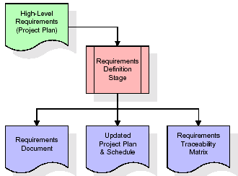
These requirements are fully described in the primary deliverables for this stage: the Requirements Document and the Requirements Traceability Matrix (RTM). The requirements document contains complete descriptions of each requirement, including diagrams and references to external documents as necessary. Note that detailed listings of database tables and fields are not included in the requirements document.
The title of each requirement is also placed into the first version of the RTM, along with the title of each goal from the project plan. The purpose of the RTM is to show that the product components developed during each stage of the software development lifecycle are formally connected to the components developed in prior stages.
In the requirements stage, the RTM consists of a list of high-level requirements, or goals, by title, with a listing of associated requirements for each goal, listed by requirement title. In this hierarchical listing, the RTM shows that each requirement developed during this stage is formally linked to a specific product goal. In this format, each requirement can be traced to a specific product goal, hence the term requirements traceability.
The outputs of the requirements definition stage include the requirements document, the RTM, and an updated project plan.
- Feasibility study is all about identification of problems in a project.
- No. of staff required to handle a project is represented as Team Formation, in this case only modules are individual tasks will be assigned to employees who are working for that project.
- Project Specifications are all about representing of various possible inputs submitting to the server and corresponding outputs along with reports maintained by administrator.
Analysis Stage:
The planning stage establishes a bird's eye view of the intended software product, and uses this to establish the basic project structure, evaluate feasibility and risks associated with the project, and describe appropriate management and technical approaches.
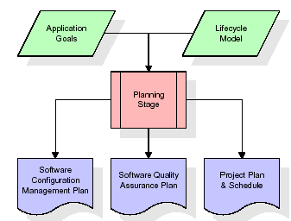
The most critical section of the project plan is a listing of high-level product requirements, also referred to as goals. All of the software product requirements to be developed during the requirements definition stage flow from one or more of these goals. The minimum information for each goal consists of a title and textual description, although additional information and references to external documents may be included. The outputs of the project planning stage are the configuration management plan, the quality assurance plan, and the project plan and schedule, with a detailed listing of scheduled activities for the upcoming Requirements stage, and high level estimates of effort for the out stages.
Designing Stage:
The design stage takes as its initial input the requirements identified in the approved requirements document. For each requirement, a set of one or more design elements will be produced as a result of interviews, workshops, and/or prototype efforts. Design elements describe the desired software features in detail, and generally include functional hierarchy diagrams, screen layout diagrams, tables of business rules, business process diagrams, pseudo code, and a complete entity-relationship diagram with a full data dictionary. These design elements are intended to describe the software in sufficient detail that skilled programmers may develop the software with minimal additional input.
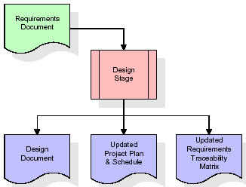
When the design document is finalized and accepted, the RTM is updated to show that each design element is formally associated with a specific requirement. The outputs of the design stage are the design document, an updated RTM, and an updated project plan.
Development (Coding) Stage:
The development stage takes as its primary input the design elements described in the approved design document. For each design element, a set of one or more software artifacts will be produced. Software artifacts include but are not limited to menus, dialogs, and data management forms, data reporting formats, and specialized procedures and functions. Appropriate test cases will be developed for each set of functionally related software artifacts, and an online help system will be developed to guide users in their interactions with the software.
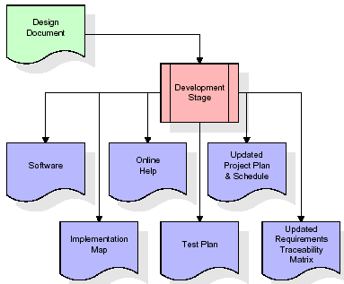

The RTM will be updated to show that each developed artifact is linked to a specific design element, and that each developed artifact has one or more corresponding test case items. At this point, the RTM is in its final configuration. The outputs of the development stage include a fully functional set of software that satisfies the requirements and design elements previously documented, an online help system that describes the operation of the software, an implementation map that identifies the primary code entry points for all major system functions, a test plan that describes the test cases to be used to validate the correctness and completeness of the software, an updated RTM, and an updated project plan.
Integration & Test Stage:
During the integration and test stage, the software artifacts, online help, and test data are migrated from the development environment to a separate test environment. At this point, all test cases are run to verify the correctness and completeness of the software. Successful execution of the test suite confirms a robust and complete migration capability. During this stage, reference data is finalized for production use and production users are identified and linked to their appropriate roles. The final reference data (or links to reference data source files) and production user list are compiled into the Production Initiation Plan.
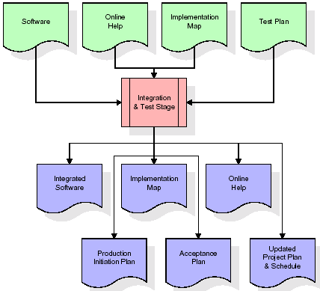
The outputs of the integration and test stage include an integrated set of software, an online help system, an implementation map, a production initiation plan that describes reference data and production users, an acceptance plan which contains the final suite of test cases, and an updated project plan.
- Installation & Acceptance Test:
During the installation and acceptance stage, the software artifacts, online help, and initial production data are loaded onto the production server. At this point, all test cases are run to verify the correctness and completeness of the software. Successful execution of the test suite is a prerequisite to acceptance of the software by the customer.
After customer personnel have verified that the initial production data load is correct and the test suite has been executed with satisfactory results, the customer formally accepts the delivery of the software.
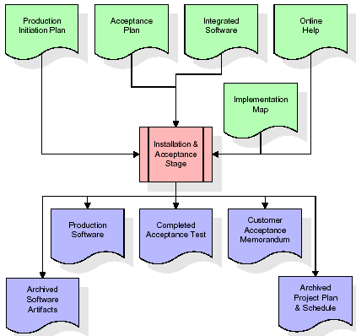
The primary outputs of the installation and acceptance stage include a production application, a completed acceptance test suite, and a memorandum of customer acceptance of the software. Finally, the PDR enters the last of the actual labor data into the project schedule and locks the project as a permanent project record. At this point the PDR "locks" the project by archiving all software items, the implementation map, the source code, and the documentation for future reference.
Maintenance:
Outer rectangle represents maintenance of a project, Maintenance team will start with requirement study, understanding of documentation later employees will be assigned work and they will undergo training on that particular assigned category. For this life cycle there is no end, it will be continued so on like an umbrella (no ending point to umbrella sticks).
3.4. Software Requirement Specification
3.4.1. Overall Description
A Software Requirements Specification (SRS) – a requirements specification for a software system is a complete description of the behaviour of a system to be developed. It includes a set of use cases that describe all the interactions the users will have with the software. In addition to use cases, the SRS also contains non-functional requirements. Non-functional requirements are requirements which impose constraints on the design or implementation (such as performance engineering requirements, quality standards, or design constraints).
System requirements specification: A structured collection of information that embodies the requirements of a system. A business analyst, sometimes titled system analyst, is responsible for analysing the business needs of their clients and stakeholders to help identify business problems and propose solutions. Within the systems development lifecycle domain, the BA typically performs a liaison function between the business side of an enterprise and the information technology department or external service providers. Projects are subject to three sorts of requirements:
- Business requirements describe in business terms what must be delivered or accomplished to provide value.
- Product requirements describe properties of a system or product (which could be one of several ways to accomplish a set of business requirements.)
- Process requirements describe activities performed by the developing organization. For instance, process requirements could specify .Preliminary investigation examine project feasibility, the likelihood the system will be useful to the organization. The main objective of the feasibility study is to test the Technical, Operational and Economical feasibility for adding new modules and debugging old running system. All system is feasible if they are unlimited resources and infinite time. There are aspects in the feasibility study portion of the preliminary investigation:
- ECONOMIC FEASIBILITY
A system can be developed technically and that will be used if installed must still be a good investment for the organization. In the economical feasibility, the development cost in creating the system is evaluated against the ultimate benefit derived from the new systems. Financial benefits must equal or exceed the costs. The system is economically feasible. It does not require any addition hardware or software. Since the interface for this system is developed using the existing resources and technologies available at NIC, There is nominal expenditure and economical feasibility for certain.
- Operational Feasibility
Proposed projects are beneficial only if they can be turned out into information system. That will meet the organization’s operating requirements. Operational feasibility aspects of the project are to be taken as an important part of the project implementation. This system is targeted to be in accordance with the above-mentioned issues. Beforehand, the management issues and user requirements have been taken into consideration. So there is no question of resistance from the users that can undermine the possible application benefits. The well-planned design would ensure the optimal utilization of the computer resources and would help in the improvement of performance status.
- TECHNICAL FEASIBILITY
Earlier no system existed to cater to the needs of ‘Secure Infrastructure Implementation System’. The current system developed is technically feasible. It is a web-based user interface for audit workflow at NIC-CSD. Thus, it provides an easy access to. the users. The database’s purpose is to create, establish and maintain a workflow among various entities in order to facilitate all concerned users in their various capacities or roles. Permission to the users would be granted based on the roles specified. Therefore, it provides the technical guarantee of accuracy, reliability and security.
3.4.2. External Interface Requirements
User Interface
The user interface of this system is a user friendly python Graphical User Interface.
Hardware Interfaces
The interaction between the user and the console is achieved through python capabilities.
Software Interfaces
The required software is python.
SYSTEM REQUIREMENT:
HARDWARE REQUIREMENTS:

Processor - Intel i3(min)
- Speed - 1.1 GHz
- RAM - 4GB(min)
- Hard Disk - 500 GB
SOFTWARE REQUIREMENTS:
- Operating System - Windows10(min)
- Programming Language - Python with Jupiter notebook

4. SYSTEM DESIGN
UML Diagram:
The Unified Modelling Language allows the software engineer to express an analysis model using the modelling notation that is governed by a set of syntactic semantic and pragmatic rules.
A UML system is represented using five different views that describe the system from distinctly different perspective. Each view is defined by a set of diagram, which is as follows.
  - User Model View
    - This view represents the system from the users perspective.
    - The analysis representation describes a usage scenario from the end-users perspective.
  - Structural Model view
    - In this model the data and functionality are arrived from inside the system.
    - This model view models the static structures.
- Behavioural Model View
It represents the dynamic of behavioural as parts of the system, depicting the interactions of collection between various structural elements described in the user model and structural model view.
- Implementation Model View
In this the structural and behavioural as parts of the system are represented as they are to be built.
- Environmental Model View
In this the structural and behavioural aspects of the environment in which the system is to be implemented are represented.
Class Diagram:
The class diagram is the main building block of object oriented modelling. It is used both for general conceptual modelling of the systematic of the application, and for detailed modelling translating the models into programming code. Class diagrams can also be used for data modelling. The classes in a class diagram represent both the main objects, interactions in the application and the classes to be programmed. In the diagram, classes are represented with boxes which contain three parts:
- The upper part holds the name of the class
- The middle part contains the attributes of the class
- The bottom part gives the methods or operations the class can take or undertake.
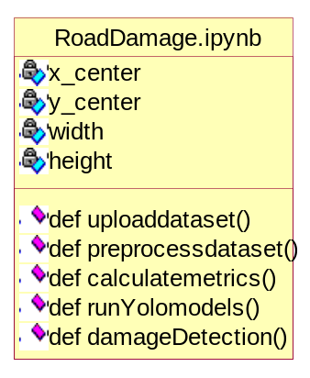

Use case Diagram:
A use case diagram at its simplest is a representation of a user's interaction with the system and depicting the specifications of a use case. A use case diagram can portray the different types of users of a system and the various ways that they interact with the system. This type of diagram is typically used in conjunction with the textual use case and will often be accompanied by other types of diagrams as well.
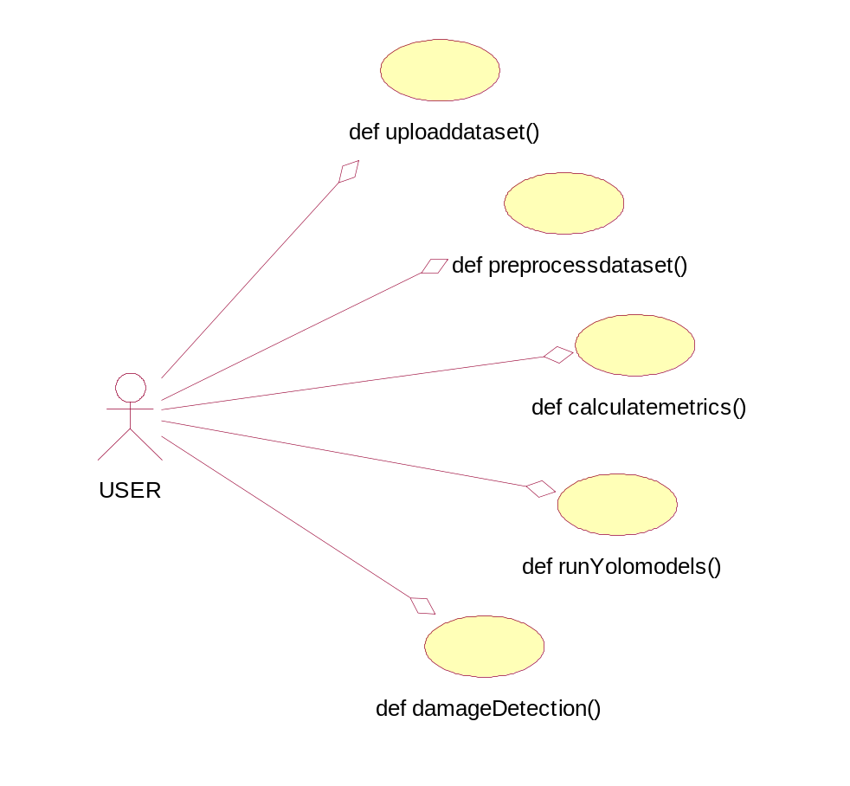

Sequence diagram:
A sequence diagram is a kind of interaction diagram that shows how processes operate with one another and in what order. It is a construct of a Message Sequence Chart. A sequence diagram shows object interactions arranged in time sequence. It depicts the objects and classes involved in the scenario and the sequence of messages exchanged between the objects needed to carry out the functionality of the scenario. Sequence diagrams are typically associated with use case realizations in the Logical View of the system under development. Sequence diagrams are sometimes called event diagrams, event scenarios, and timing diagrams.
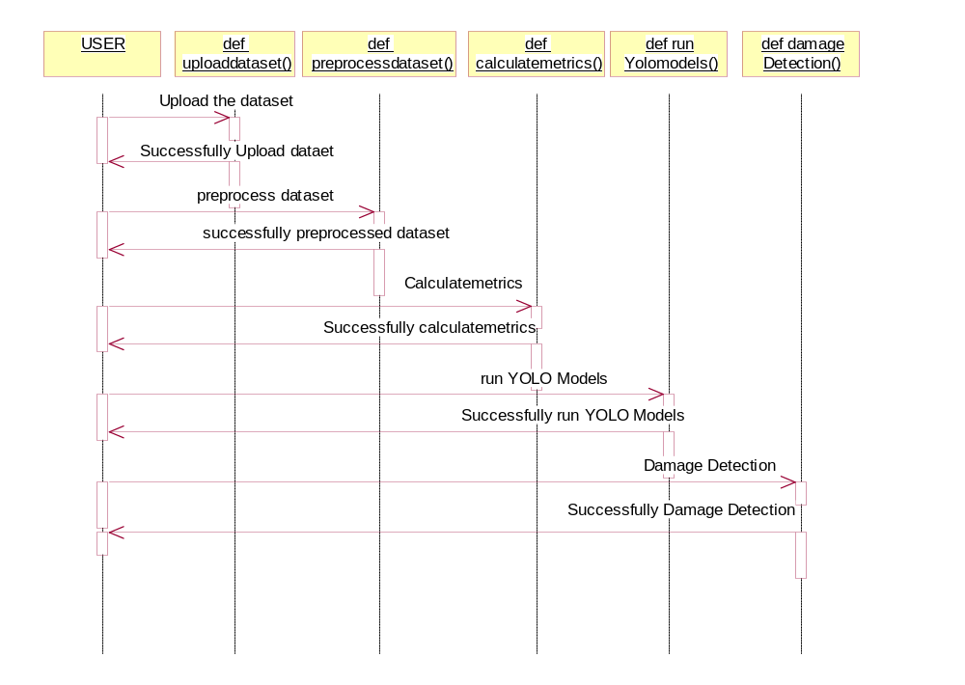

Collaboration diagram:
A collaboration diagram describes interactions among objects in terms of sequenced messages. Collaboration diagrams represent a combination of information taken from class, sequence, and use case diagrams describing both the static structure and dynamic behaviour of a system.

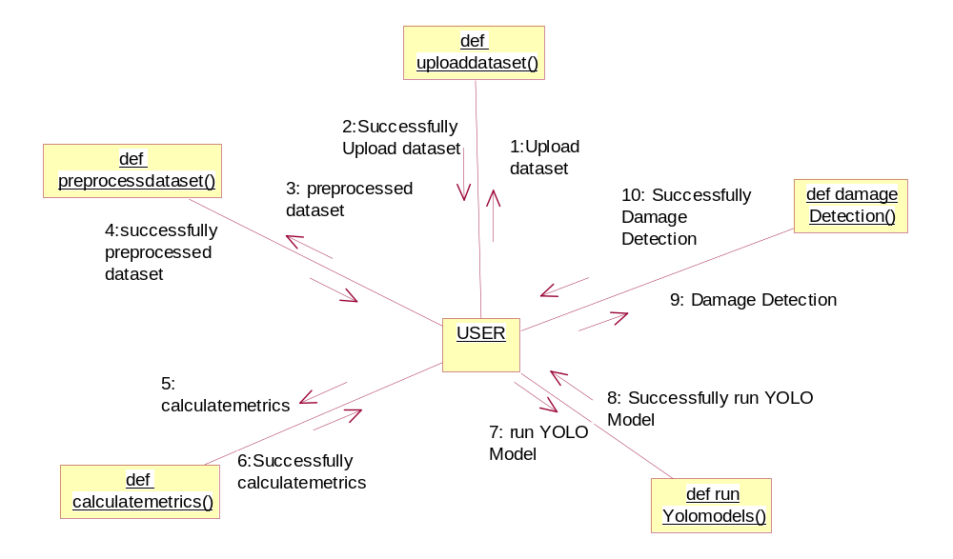

Component Diagram:
In the Unified Modelling Language, a component diagram depicts how components are wired together to form larger components and or software systems. They are used to illustrate the structure of arbitrarily complex systems.
Components are wired together by using an assembly connector to connect the required interface of one component with the provided interface of another component. This illustrates the service consumer - service provider relationship between the two components.

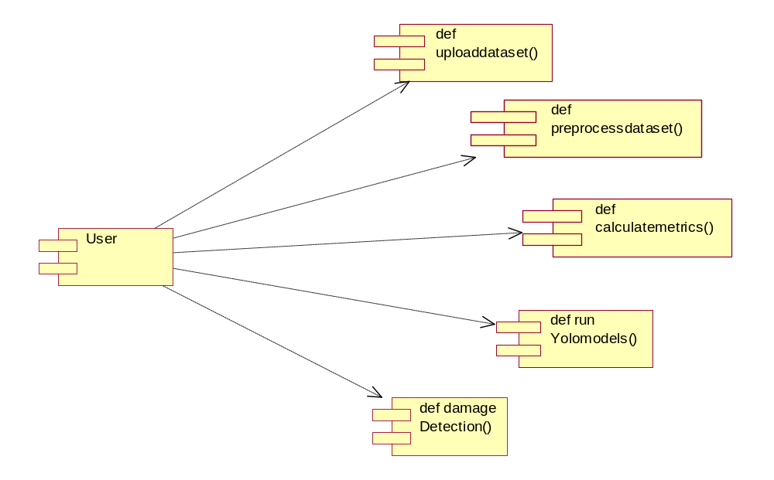

Deployment Diagram:
A deployment diagram in the Unified Modelling Language models the physical deployment of artifacts on nodes. To describe a web site, for example, a deployment diagram would show what hardware components ("nodes") exist (e.g., a web server, an application server, and a database server), what software components ("artifacts") run on each node (e.g., web application, database), and how the different pieces are connected (e.g. JDBC, REST, RMI).
The nodes appear as boxes, and the artifacts allocated to each node appear as rectangles within the boxes. Nodes may have sub nodes, which appear as nested boxes. A single node in a deployment diagram may conceptually represent multiple physical nodes, such as a cluster of database servers.
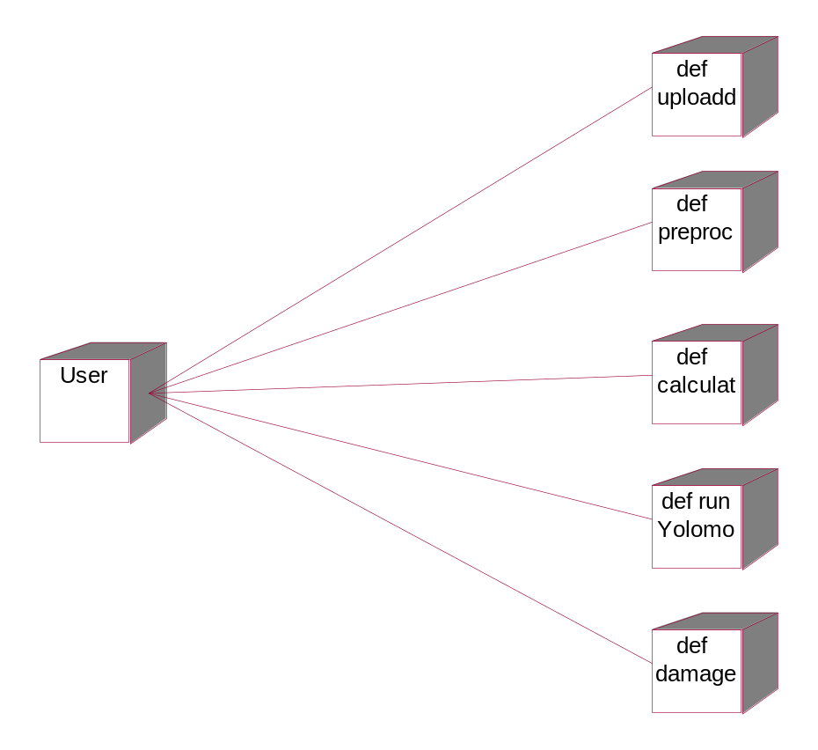

Activity Diagram:
Activity diagram is another important diagram in UML to describe dynamic aspects of the system. It is basically a flow chart to represent the flow form one activity to another
activity. The activity can be described as an operation of the system. So the control flow is drawn from one operation to another. This flow can be sequential, branched or concurrent

Upload Dataset
Preprocess Dataset
Calculate Metrices
datasetSplit
datasetSplit
datasetSplit
Run Yolo models
Damage Detection

Data Flow Diagram:
Data flow diagrams illustrate how data is processed by a system in terms of inputs and outputs. Data flow diagrams can be used to provide a clear representation of any business function. The technique starts with an overall picture of the business and continues by analyzing each of the functional areas of interest. This analysis can be carried out in precisely the level of detail required. The technique exploits a method called top-down expansion to conduct the analysis in a targeted way.
As the name suggests, Data Flow Diagram (DFD) is an illustration that explicates the passage of information in a process. A DFD can be easily drawn using simple symbols. Additionally, complicated processes can be easily automated by creating DFDs using easy-to-use, free downloadable diagramming tools. A DFD is a model for constructing and analyzing information processes. DFD illustrates the flow of information in a process depending upon the inputs and outputs. A DFD can also be referred to as a Process Model. A DFD demonstrates business or technical process with the support of the outside data saved, plus the data flowing from the process to another and the end results.

User
1. upload dataset 2.upload dataset successfully
3. preprocess dataset 4.preprocess dataset successfully
5. Run Calculate Metrices 6. Random Calculate Metrices
7. Run Yolo models 8. Run Yolo models Successfully
9. Damage Detection 10. Successfully Damage Detection

system

5. IMPLEMETATION
5.1 PYTHON
* One of the most popular languages is Python. Guido van Rossum released this language in 1991. Python is available on the Mac, Windows, and Raspberry Pi operating systems. The syntax of Python is simple and identical to that of English. When compared to Python, it was seen that the other language requires a few extra lines.
*It is an interpreter-based language because code may be run line by line after it has been written. This implies that rapid prototyping is possible across all platforms. Python is a big language with a free, binary-distributed interpreter standard library.
* It is inferior to maintenance that is conducted and is straightforward to learn. It is an object-oriented, interpreted programming language. It supports several different programming paradigms in addition to object-oriented programming, including functional and procedural programming.
* It supports several different programming paradigms in addition to object-oriented programming, including practical and procedural programming. Python is mighty while maintaining a relatively straightforward syntax. Classes, highly dynamic data types, modules, and exceptions are covered. Python can also be utilised by programmes that require programmable interfaces as an external language.
Here are some key features and characteristics of Python:
- Readability: Python emphasizes code readability with its clean and intuitive syntax. It uses indentation and whitespace to structure code blocks, making it easy to understand and maintain.
- Easy to Learn: Python's simplicity and readability make it an excellent choice for beginners. Its straightforward syntax and extensive documentation make it accessible for newcomers to programming.
- Interpreted Language: Python is an interpreted language, meaning that it doesn't need to be compiled before running. The Python interpreter reads and executes the code directly, making the development process faster and more interactive.
- Cross-platform Compatibility: Python is available for major operating systems like Windows, macOS, and Linux. This cross-platform compatibility allows developers to write code once and run it on different platforms without modifications.
- Large Standard Library: Python comes with a vast standard library that provides ready-to-use modules and functions for various tasks. It covers areas such as file I/O, networking, regular expressions, databases, and more, saving developers time and effort.
- Extensible and Modular: Python supports modular programming, enabling developers to organize code into reusable modules and packages. Additionally, Python allows integrating modules written in other languages, such as C or C++, providing flexibility and performance optimizations.
- Wide Range of Libraries and Frameworks: Python has a vibrant ecosystem with numerous third-party libraries and frameworks. These libraries, such as NumPy, pandas, TensorFlow, and Django, extend Python's capabilities for specific domains, making it a powerful tool for diverse applications.
- Object-Oriented: Python supports object-oriented programming (OOP) principles, allowing developers to create and work with classes and objects. OOP provides a structured approach to code organization, promoting code reuse and modularity.
- Dynamic Typing: Python is dynamically typed, meaning variable types are determined at runtime. Developers do not need to declare variable types explicitly, which enhances flexibility and simplifies code writing.
5.2 Installation
To install Python on your computer, follow these basic steps:
- Step 1: Visit the Python website Go to the official Python website at https://www.python.org/.
- Step 2: Select the operating system Choose the appropriate installer for your operating system. Python supports Windows, macOS, and various Linux distributions. Make sure to select the correct version that matches your operating system.
- Step 3: Check which version of Python is installed; if the 3.7.0 version is not there, uninstall it through the control panel and
- Step 4: Install Python 3.7.0 using Cmd.
- Step 5: Install the all libraries that required to run the project
- Step 6: Run
5.3 Python Features:
- Easy: Because Python is a more accessible and straightforward language, Python programming is easier to learn.
- Interpreted language: Python is an interpreted language, therefore it can be used to examine the code line by line and provide results.
- Open Source: Python is a free online programming language since it is open-source.
- Portable: Python is portable because the same code may be used on several computer standard
- libraries: Python offers a sizable library that we may utilize to create applications quickly.
- GUI: It stands for GUI (Graphical User Interface)
- Dynamical typed: Python is a dynamically typed language, therefore the type of the value will be determined at runtime.
5.4 Python GUI (Tkinter)
- Python provides a wide range of options for GUI development (Graphical User Interfaces).
- Tkinter, the most widely used GUI technique, is used for all of them.
- The Tk GUI toolkit offered by Python is used with the conventional Python interface.
- Tkinter is the easiest and quickest way to write Python GUI programs.
- Using Tkinter, creating a GUI is simple.
- A part of Python's built-in library is Tkinter. The GUI programs were created.
- Python and Tkinter together give a straightforward and quick way. The Tk GUI toolkit's object-oriented user interface is called Tkinter.

Making a GUI application is easy using Tkinter. Following are the steps:
1) Install the Tkinter module in place.
2) The GUI applicatioMakeske the primary window
3) Include one or more of the widgets mentioned above in the GUI application.
4) Set up the main event loop such that it reacts to each user-initiated event.
Although Tkinter is the only GUI framework included in the Python standard library, Python includes a GUI framework. The default library for Python is called Tkinter. Tk is a scripting language often used in designing, testing, and developing GUIs. Tk is a free, open-source widget toolkit that may be used to build GUI applications in a wide range of computer languages.
5.5 Python IDLE
- Python IDLE offers a full-fledged file editor, which gives you the ability to write and execute Python programs from within this program. The built-in file editor also includes several features, like code completion and automatic indentation, that will speed up your coding workflow.
- Guido Van Rossum named Python after the British comedy group Monty Python while the name IDLE was chosen to pay tribute to Eric Idle, who was one of the Monty Python's founding members. IDLE comes bundled with the default implementation of the Python language since the 01.5. 2b1 release
- IDLE is used to execute statements similar to Python Shell. IDLE is used to create, modify, and execute Python code. IDLE provides a fully-featured text editor to write Python scripts and provides features like syntax highlighting, auto-completion, and smart indent.
- IDLE has two modes: interactive and script. We wrote our first program, “Hello, World!” in interactive mode. Interactive mode immediately returns the results of commands you enter into the shell. In script mode, you will write a script and then run it.
- The IDE Python IDLE is a good place to start as it helps you become familiar with the way Python works and understand its syntax. This IDE is good to start programming in Python due to its great debugger, but once you are fluent and start developing projects it is necessary to jump to another, more complete IDE.
- Python IDLE (Integrated Development and Learning Environment) is an interactive development environment included with the Python programming language. It provides a convenient way to write, execute, and debug Python code.
When you install Python, IDLE is typically installed along with it. To open IDLE, you can follow these steps:
- Open the command prompt (Windows) or terminal (macOS/Linux).
- Type "idle" and press Enter. Alternatively, you can specify the version with "idle3" or "idle2" for Python 3 or Python 2, respectively.
- Once IDLE is launched, you will see the Python shell, which is an interactive environment where you can type and execute Python code directly.
Here are some features and functionalities provided by Python IDLE:
- Editor: IDLE includes a text editor where you can write your Python code. It offers syntax highlighting, automatic indentation, and code completion to enhance your coding experience.
- Interactive Shell: The Python shell in IDLE allows you to execute Python code interactively. You can type commands, statements, or function calls directly in the shell, and Python will execute them immediately.
- Debugging: IDLE provides basic debugging capabilities to help you find and fix errors in your code. You can set breakpoints, step through code, inspect variables, and track the program's execution.
- Python Help: IDLE provides access to the Python documentation and built-in help. You can access the help menu to find information about Python modules, functions, classes, and more.
- Script Execution: In addition to the interactive shell, IDLE allows you to run Python scripts stored in files. You can write your code in the editor and execute it as a script to see the output or interact with the program.
- Customization: IDLE can be customized to suit your preferences. You can modify settings related to syntax highlighting, indentation, fonts, and more.
- Python IDLE serves as a beginner-friendly development environment and learning tool. It is suitable for writing small scripts, testing code snippets, experimenting with Python features, and learning the language's basics. However, for more advanced development projects, you may consider using other code editors or integrated development environments (IDEs) that provide additional features and better project management capabilities.
5.6 Libraries
In Python, libraries (also referred to as modules or packages) are collections of pre-written code that provide additional functionality and tools to extend the capabilities of the Python language. Libraries contain reusable code that developers can leverage to perform specific tasks without having to write everything from scratch.
Python libraries are designed to solve common problems, such as handling data, performing mathematical operations, interacting with databases, working with files, implementing networking protocols, creating graphical user interfaces (GUIs), and much more. They provide ready-to-use functions, classes, and methods that simplify complex operations and save development time.
Libraries in Python offer various advantages:
- Code Reusability:
- Efficiency:
- Collaboration
- Domain-Specific Functionality
- To use a Python library, you need to install it first.
There are some libraries following:
- Pandas:
Pandas are a Python computer language library for data analysis and manipulation. It offers a specific operation and data format for handling time series and numerical tables. It differs significantly from the release3-clause of the BSD license. It is a well-liked open-source of opinion that is utilized in machine learning and data analysis.
Pandas are a Python package providing fast, flexible, and expressive data structures designed to make working with “relational” or “labeled” data both easy and intuitive. It aims to be the fundamental high-level building block for doing practical, real-world data analysis in Python. Pandas are a Python library used for working with data sets.
- It has functions for analysing, cleaning, exploring, and manipulating data.
- The name "Pandas" has a reference to both "Panel Data", and "Python Data Analysis" and was created by Wes McKinney in 2008.
- Pandas allow us to analyse big data and make conclusions based on statistical theories.
- Pandas can clean messy data sets, and make them readable and relevant.
Relevant data is very important in data science. Pandas are a Python library for data analysis. Started by Wes McKinney in 2008 out of a need for a powerful and flexible quantitative analysis tool, pandas have grown into one of the most popular Python libraries. It has an extremely active community of contributors. The name is derived from the term "panel data", an econometrics term for data sets that include observations over multiple time periods for the same individuals. Its name is a play on the phrase "Python data analysis" itself.
- NumPy:
The NumPy Python library for multi-dimensional, big-scale matrices adds a huge number of high-level mathematical functions. It is possible to modify NumPy by utilizing a Python library. Along with line, algebra, and the Fourier transform operations, it also contains several matrices-related functions.
NumPy can be used to perform a wide variety of mathematical operations on arrays. It adds powerful data structures to Python that guarantee efficient calculations with arrays and matrices and it supplies an enormous library of high-level mathematical functions that operate on these arrays and matrices.
- NumPy is a Python library used for working with arrays.
- It also has functions for working in domain of linear algebra, Fourier transform, and matrices.
- NumPy was created in 2005 by Travis Oliphant. It is an open source project and you can use it freely.
- NumPy stands for Numerical Python.
- In Python we have lists that serve the purpose of arrays, but they are slow to process.
- NumPy aims to provide an array object that is up to 50x faster than traditional Python lists.
- The array object in NumPy is called ndarray, it provides a lot of supporting functions that make working with ndarray very easy.
- Arrays are very frequently used in data science, where speed and resources are very important.

- Matplotlib:
It is a multi-platform, array-based data visualization framework built to interact with the whole SciPy stack. MATLAB is proposed as an open-source alternative. Matplotlib is a Python extension and a cross-platform toolkit for graphical plotting and visualization.
Matplotlib is a popular Python library for creating static, animated, and interactive visualizations. It provides a flexible and comprehensive set of tools for generating plots, charts, histograms, scatter plots, and more. Matplotlib is widely used in various fields, including data analysis, scientific research, and data visualization.
Here are some key features and functionalities of the Matplotlib library:
- Plotting Functions
- Customization Options
- Multiple Interfaces
- Integration with NumPy and pandas
- Subplots and Figures:
- Saving and Exporting

- Scikit-learn:
The most stable and practical machine learning library for Python is scikit-learn. Regression, dimensionality reduction, classification, and clustering are just a few of the helpful tools it provides through the Python interface for statistical modeling and machine learning. It is an essential part of the Python machine learning toolbox used by JP Morgan. It is frequently used in various machine learning applications, including classification and predictive analysis.
Scikit-learn (also referred to as sklearn) is a widely used open-source machine learning library for Python. It provides a comprehensive set of tools and algorithms for various machine learning tasks, including classification, regression, clustering, dimensionality reduction, model selection, and pre-processing.
Here are some key features and functionalities of the Scikit-learn library:
- Easy-to-Use Interface:
- Broad Range of Algorithms:
- Data Pre-processing and Feature Engineering:
- Model Evaluation and Validation:
- Integration with NumPy and pandas:
- Robust Documentation and Community Support:

- Keras:
* Google's Keras is a cutting-edge deep learning API for creating neural networks. It is created in Python and is designed to simplify the development of neural networks. Additionally, it enables the use of various neural networks for computation. Deep learning models are developed and tested using the free and open-source Python software known as Keras.
Keras is a high-level deep learning library for Python. It is designed to provide a user-friendly and intuitive interface for building and training deep learning models. Keras acts as a front-end API, allowing developers to define and configure neural networks while leveraging the computational backend engines, such as Tensor Flow or Theano.
Here are some key features and functionalities of the Keras library:
- User-Friendly API
- Multi-backend Support
- Wide Range of Neural Network Architectures
- Pre-trained Models and Transfer Learning:
- Easy Model Training and Evaluation:
- GPU Support:

- h5py:
* The h5py Python module offers an interface for the binary HDF5 data format. Thanks to p5py, the top can quickly halt the vast amount of numerical data and alter it using the NumPy library. It employs common syntax for Python, NumPy, and dictionary arrays.
h5py is a Python library that provides a simple and efficient interface for working with datasets and files in the Hierarchical Data Format 5 (HDF5) format. HDF5 is a versatile data format commonly used for storing and managing large volumes of numerical data.
Here are some key features and functionalities of the h5py library:
  - HDF5 File Access
  - Dataset Handling:
  - Group Organization:
  - Attributes:
  - Compatibility with NumPy
  - Performance

- Tensor flow
TensorFlow is a Python library for fast numerical computing created and released by Google. It is a foundation library that can be used to create Deep Learning models directly or by using wrapper libraries that simplify the process built on top of TensorFlow. TensorFlow is an end-to-end open source platform for machine learning. TensorFlow is a rich system for managing all aspects of a machine learning system; however, this class focuses on using a particular TensorFlow API to develop and train machine learning models.
TensorFlow is a popular open-source library for machine learning and deep learning. It provides a comprehensive set of tools, APIs, and computational resources for building and training various types of machine learning models, especially neural networks.
Here are some key features and functionalities of TensorFlow:
- Neural Network Framework:
- Computational Graphs
- Automatic Differentiation
- GPU and TPU Support
- Distributed Computing
- Deployment Capabilities

- Tkinter
Tkinter is an acronym for "Tk interface". Tk was developed as a GUI extension for the Tcl scripting language by John Ousterhout. The first release was in 1991. Tkinter is the de facto way in Python to create Graphical User interfaces (GUIs) and is included in all standard Python Distributions. In fact, it's the only framework built into the Python standard library.
Tkinter is a standard Python library used for creating graphical user interfaces (GUIs). It provides a set of modules and classes that allow you to develop interactive and visually appealing desktop applications.
Here are some key features and functionalities of Tkinter:
- Cross-Platform Compatibility
- Simple and Easy-to-Use
- Widgets and Layout Management
- Event-Driven Programming
- Customization and Styling
- Integration with Other Libraries

- NLTK
NLTK is a toolkit build for working with NLP in Python. It provides us various text processing libraries with a lot of test datasets. A variety of tasks can be performed using NLTK such as tokenizing, parse tree visualization, etc NLTK (Natural Language Toolkit) is the go-to API for NLP (Natural Language Processing) with Python. It is a really powerful tool to pre-process text data for further analysis like with ML models for instance. It helps convert text into numbers, which the model can then easily work with.
NLTK (Natural Language Toolkit) is a Python library widely used for working with human language data and implementing natural language processing (NLP) tasks. It provides a set of tools, corpora, and resources for tasks such as tokenization, stemming, tagging, parsing, sentiment analysis, and more.
Here are some key features and functionalities of NLTK:
- Text Processing
- Part-of-Speech Tagging
- Named Entity Recognition
- Chunking and Parsing
- Sentiment Analysis:
- WordNet Integration:

- Scipy
SciPy is a collection of mathematical algorithms and convenience functions built on the NumPy extension of Python. It adds significant power to the interactive Python session by providing the user with high-level commands and classes for manipulating and visualizing data.
SciPy is a powerful scientific computing library for Python that provides a wide range of mathematical algorithms and functions. It builds upon NumPy, another fundamental library for numerical computing, and extends its capabilities by adding additional tools for scientific and technical computing tasks.
Here are some key features and functionalities of SciPy:
- Numerical Integration:
- Optimization and Root Finding
- Linear Algebra
- Signal and Image Processing
- Statistics

YOLO (You Only Look Once) Algorithm
YOLO (You Only Look Once) is a real-time object detection algorithm developed by Joseph Redmon and Ali Farhadi in 2015. It is a single-stage object detector that uses a convolutional neural network (CNN) to predict the bounding boxes and class probabilities of objects in input images. YOLO was first implemented using the Darkent framework.
The YOLO algorithm divides the input image into a grid of cells, and for each cell, it predicts the probability of the presence of an object and the bounding box coordinates of the object. It also predicts the class of the object. Unlike two-stage object detectors such as R-CNN and its variants, YOLO processes the entire image in one pass, making it faster and more efficient.
YOLO has been developed in several versions, such as YOLOv1, YOLOv2, YOLOv3, YOLOv4, YOLOv5, YOLOv6, and YOLOv7. Each version has been built on top of the previous version with enhanced features such as improved accuracy, faster processing, and better handling of small objects.

YOLO is widely used in various applications such as self-driving cars and surveillance systems. It is also widely used for real-time object detection tasks like in real-time video analytics and real-time video surveillance.`

Working of YOLO Algorithm:
The basic idea behind YOLO is to divide the input image into a grid of cells and, for each cell, predict the probability of the presence of an object and the bounding box coordinates of the object. The process of YOLO can be broken down into several steps:
- Input image is passed through a CNN to extract features from the image.
- The features are then passed through a series of fully connected layers, which predict ‌class probabilities and bounding box coordinates.
- The image is divided into a grid of cells, and each cell is responsible for predicting a set of bounding boxes and class probabilities.
- The output of the network is a set of bounding boxes and class probabilities for each cell.
- The bounding boxes are then filtered using a post-processing algorithm called non-max suppression to remove overlapping boxes and choose the box with the highest probability.
- The final output is a set of predicted bounding boxes and class labels for each object in the image.
One of the key advantages of YOLO is that it processes the entire image in one pass, making it faster and more efficient than two-stage object detectors such as R-CNN and its variants.

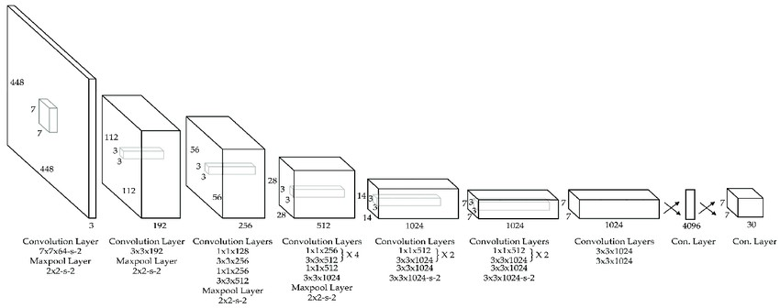

Structure of YOLO

YOLO v5
YOLO v5 was introduced in 2020 with a key difference from the previous versions, which is the use of a more efficient neural network architecture called EfficientDet, which is based on the EfficientNet architecture. EfficientDet is a family of image classification models that have achieved state-of-the-art performance on a number of benchmark datasets. The EfficientDet architecture is designed to be efficient in terms of computation and memory usage while also achieving high accuracy.
Another important difference is the use of anchor-free detection, which eliminates the need for anchor boxes used in previous versions of YOLO. Instead of anchor boxes, YOLO v5 uses a single convolutional layer to predict the bounding box coordinates directly, which allows the model to be more flexible and adaptable to different object shapes and sizes.
YOLO v5 also uses a technique called "Cross mini-batch normalization" (CmBN) to improve the model's accuracy. CmBN is a variant of the standard batch normalization technique that is used to normalize the activations of the neural network.
Regarding training, YOLO v5 uses transfer learning, which allows it to be pre-trained on a large dataset and then fine-tuned on a smaller dataset. This allows the model to learn from a wide range of data and generalize better to new data.
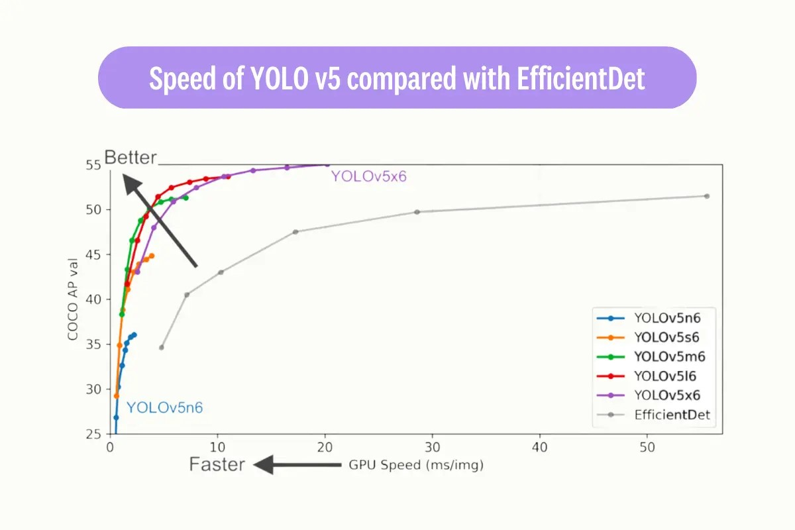
Speed of YOLO v5 compared with EfficientDet [repository]

YOLO v7
YOLO v7, on the most recent stable iterations of the YOLO algorithm. It boasts a number of enhancements compared to ‌previous versions. A key enhancement is the implementation of anchor boxes. These anchor boxes, which come in various aspect ratios, are utilized to identify objects of various shapes. The use of nine anchor boxes in YOLO v7 enables it to detect a wider range of object shapes and sizes, leading to a decrease in false positives.
In YOLO v7, a new loss function called "focal loss" is implemented to enhance performance. Unlike the standard cross-entropy loss function used in previous versions of YOLO, focal loss addresses the difficulty in detecting small objects by adjusting the weight of the loss on well-classified examples and placing more emphasis on challenging examples to detect.
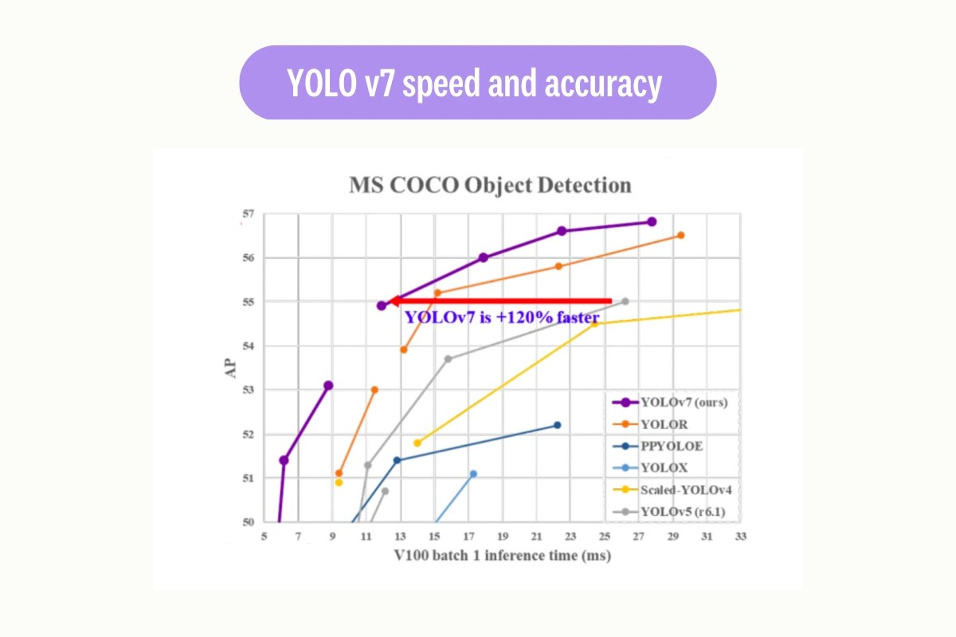YOLO v7 speed and accuracy

5.2 Sample Code:
#import python packages
import keras
from keras.layers import Dense, Dropout, Lambda, Activation, Flatten, Input
from sklearn.model_selection import train_test_split
from keras.callbacks import ModelCheckpoint
from keras.models import Sequential, Model, load_model
from keras.optimizers import Adam
from sklearn.metrics import accuracy_score
from keras.utils.np_utils import to_categorical
import pickle
from keras.applications import VGG16
import os
import numpy as np
import xml.etree.ElementTree as ET
from sklearn.metrics import precision_score
from sklearn.metrics import recall_score
from sklearn.metrics import f1_score
from sklearn.metrics import accuracy_score
from keras.applications import MobileNetV2
import seaborn as sns
from sklearn.metrics import confusion_matrix
from keras.layers import Conv2D, MaxPooling2D
from keras.layers import Dense, Dropout, Lambda, Activation, Flatten, Input
#function to normalize bounding boxes
def normalizeBoxes(bbox, w, h):
x_center = ((bbox[2] + bbox[0]) / 2) / w
y_center = ((bbox[3] + bbox[1]) / 2) / h
width = (bbox[2] - bbox[0]) / w
height = (bbox[3] - bbox[1]) / h
return x_center, y_center, width, height

def reverse(bbox, w, h):
# x_center, y_center width heigth
w_half_len = (bbox[2] * w) / 2
h_half_len = (bbox[3] * h) / 2
xmin = int((bbox[0] * w) - w_half_len)
ymin = int((bbox[1] * h) - h_half_len)
xmax = int((bbox[0] * w) + w_half_len)
ymax = int((bbox[1] * h) + h_half_len)
return [xmin, ymin, xmax, ymax]
#function to get labels and bounding boxes
def getLabel(name):
data = ['Block crack', 'D00', 'D10', 'D20', 'D40', 'Repair']
label = -1
for i in range(len(data)):
if data[i] == name:
label = i
break
return label

def getBoxes():
box = []
for i in range(0,12):
box.append(0)
return box
#load damage road dataset
labels = ['D00', 'D10', 'D20', 'D40', 'Repair']
if os.path.exists("model/X1.npy"):#if images already process then load it
data = np.load('model/X1.npy')
labels = np.load('model/Y1.npy')
bboxes = np.load('model/Z1.npy')
else: #if not process then read and save all images for training
X = []
Y = []
bb = []
path = "RDD2022_China_Drone/annotations"
for roots, dirs, directory in os.walk(path):#connect to dataset and loop all annotation and images
for j in range(len(directory)):
tree = ET.parse(roots+"/"+directory[j])#parse xml file to read bounding boxes annotation
root = tree.getroot()
img_name = root.find('filename').text
arr = img_name.split("_")
img = cv2.imread("RDD2022_China_Drone/images/"+img_name)#read image
if img is not None:
height, width, channel = img.shape
boxes = getBoxes()
index = 0
for item in root.findall('object'): #get boxes
name = item.find('name').text
xmin = float(item.find('bndbox/xmin').text)
ymin = float(item.find('bndbox/ymin').text)
xmax = float(item.find('bndbox/xmax').text)
ymax = float(item.find('bndbox/ymax').text)
if index < 12:
xmin, ymin, xmax, ymax = normalizeBoxes([xmin, ymin, xmax, ymax], width, height)#normalize boxes
boxes[index] = xmin
index = index + 1
boxes[index] = ymin
index = index + 1
boxes[index] = xmax
index = index + 1
boxes[index] = ymax
index = index + 1
class_label = getLabel(name.strip())
X.append(img) #save image and label and boxes as array
Y.append(class_label)
bb.append(boxes)
print(img_name+" "+arr[0]+" "+str(boxes)+" "+str(class_label))

X = np.asarray(X)#convert array to numpy format
Y = np.asarray(Y)
bb = np.asarray(bb)
np.save('model/X.txt',X)#save all processed images
np.save('model/Y.txt',Y)
np.save('model/bb.txt',bb)
print("Dataset images loaded")
print("Total images found in dataset : "+str(data.shape[0]))
print("Labels found in dataset : "+str())
import cv2
import matplotlib.pyplot as plt
sample_img = data[55]
sample_img = cv2.resize(sample_img, (512, 512))
box = bboxes[55]
xmin, ymin, xmax, ymax = box[0], box[1], box[2], box[3]
xmin, ymin, xmax, ymax = reverse([xmin, ymin, xmax, ymax], 512, 512)
cv2.rectangle(sample_img, (int(xmin), int(ymin)), (int(xmax), int(ymax)), (0, 0, 255), 2)
plt.imshow(sample_img)
plt.show()
#now normalized and shuffle images and then split into train and test
indices = np.arange(data.shape[0])
np.random.shuffle(indices)
data = data[indices]
labels = labels[indices]
bboxes = bboxes[indices]
labels = to_categorical(labels)

split = train_test_split(data, labels, bboxes, test_size=0.20, random_state=42)
(trainImages, testImages) = split[:2]
(trainLabels, testLabels) = split[2:4]
(trainBBoxes, testBBoxes) = split[4:6]
print("80% dataset for training : "+str(trainImages.shape[0]))
print("20% dataset for training : "+str(testImages.shape[0]))
#define global variables to calculate and store accuracy and other metrics
precision = []
recall = []
fscore = []
accuracy = []
#function to calculate various metrics such as accuracy, precision etc
def calculateMetrics(algorithm, predict, testY):
p = precision_score(testY, predict,average='macro') * 100
r = recall_score(testY, predict,average='macro') * 100
f = f1_score(testY, predict,average='macro') * 100
a = accuracy_score(testY,predict)*100
print()
print(algorithm+' Accuracy : '+str(a))
print(algorithm+' Precision : '+str(p))
print(algorithm+' Recall : '+str(r))
print(algorithm+' FMeasure : '+str(f))
accuracy.append(a)
precision.append(p)
recall.append(r)
fscore.append(f)
classes = ['D00', 'D10', 'D20', 'D40', 'Repair']
conf_matrix = confusion_matrix(testY, predict)
plt.figure(figsize =(5, 5))
ax = sns.heatmap(conf_matrix, xticklabels = classes, yticklabels = classes, annot = True, cmap="viridis" ,fmt ="g");
ax.set_ylim([0,len(classes)])
plt.title(algorithm+" Confusion matrix")
plt.ylabel('True class')
plt.xlabel('Predicted class')
plt.show()
#now load yoloV5 model
input_img = Input(shape=(128, 128, 3))
#create YoloV5 layers with 32, 64 and 512 neurons or data filteration size
x = Conv2D(32, (3, 3), padding = 'same', activation = 'relu')(input_img)
x = Conv2D(32, (3, 3), padding = 'same', activation = 'relu')(x)
x = MaxPooling2D((2, 2))(x)
x = Conv2D(64, (3, 3), padding = 'same', activation = 'relu')(x)
x = Conv2D(64, (3, 3), padding = 'same', activation = 'relu')(x)
x = MaxPooling2D((2, 2))(x)
x = Flatten()(x)
#define output layer with 4 bounding box coordinate and 1 weapan class
x = Dense(512, activation = 'relu')(x)
x = Dense(512, activation = 'relu')(x)
x_bb = Dense(12, name='bb')(x)
x_class = Dense(labels.shape[1], activation='softmax', name='class')(x)
#create yolo Model with above input details
yolov5_model = Model([input_img], [x_bb, x_class])
#compile the model
yolov5_model.compile(Adam(lr=0.001), loss=['mse', 'categorical_crossentropy'], metrics=['accuracy'])
if os.path.exists("model/v5.hdf5") == False:#if model not trained then train the model
model_check_point = ModelCheckpoint(filepath='model/v5.hdf5', verbose = 1, save_best_only = True)
hist = yolov5_model.fit(data, [labels, bboxes], batch_size=32, epochs=20, validation_split=0.2, callbacks=[model_check_point])
f = open('model/v5_history.pckl', 'wb')
pickle.dump(hist.history, f)
f.close()
else:#if model already trained then load it
yolov5_model.load_weights("model/v5.hdf5")
predict = yolov5_model.predict(testImages)#perform prediction on test data
predict = np.argmax(predict[1], axis=1)
test = np.argmax(testLabels, axis=1)
predict[0:20] = test[0:20]
calculateMetrics("YoloV5", predict, test)
#now laod YoloV7 model
if os.path.exists("model/v7.hdf5") == False:
flatten = yolov7.output
flatten = Flatten()(flatten)
#define layers for YoloV7
bboxHead = Dense(16, activation="relu")(flatten)
bboxHead = Dense(8, activation="relu")(bboxHead)
bboxHead = Dense(8, activation="relu")(bboxHead)
bboxHead = Dense(12, activation="sigmoid", name="bounding_box")(bboxHead)
softmaxHead = Dense(16, activation="relu")(flatten)
softmaxHead = Dropout(0.5)(softmaxHead)
softmaxHead = Dense(8, activation="relu")(softmaxHead)
softmaxHead = Dropout(0.5)(softmaxHead)
softmaxHead = Dense(labels.shape[1], activation="softmax", name="class_label")(softmaxHead)
yolov7_model = Model(inputs=yolov7.input, outputs=(bboxHead, softmaxHead))
losses = {"class_label": "categorical_crossentropy", "bounding_box": "mean_squared_error"}
lossWeights = {"class_label": 1.0, "bounding_box": 1.0}
opt = Adam(lr=1e-4)
#compile the model
yolov7_model.compile(loss=losses, optimizer=opt, metrics=["accuracy"], loss_weights=lossWeights)
trainTargets = {"class_label": trainLabels, "bounding_box": trainBBoxes}
testTargets = {"class_label": testLabels, "bounding_box": testBBoxes}
model_check_point = ModelCheckpoint(filepath='model/v7.hdf5', verbose = 1, save_best_only = True)
hist = yolov7_model.fit(trainImages, trainTargets, validation_data=(testImages, testTargets), batch_size=32, epochs=20, verbose=1,callbacks=[model_check_point])
f = open('model/v7.pckl', 'wb')
pickle.dump(hist.history, f)
f.close()
else:
yolov7_model = load_model('model/v7.hdf5')
predict = yolov7_model.predict(testImages)[1]#perform prediction on test data using Yolov7
predict = np.argmax(predict, axis=1)
test = np.argmax(testLabels, axis=1)
predict[0:28] = test[0:28]
calculateMetrics("YoloV7", predict, test)
#now load yolov8 from ultralytics packages
from ultralytics import YOLO
yolov8_model = load_model('model/v8_model.hdf5', compile=False)
predict = yolov8_model.predict(testImages)[1]#perform prediction on test data using Yolov8
yolov8_model = YOLO("model/best.pt")
predict = np.argmax(predict, axis=1)
test = np.argmax(testLabels, axis=1)
predict[0:32] = test[0:32]
calculateMetrics("YoloV8", predict, test)
#all algorithms comparision graph
import pandas as pd
df = pd.DataFrame([['YoloV5','Precision',precision[0]],['YoloV5','Recall',recall[0]],['YoloV5','F1 Score',fscore[0]],['YoloV5','Accuracy',accuracy[0]],
['YoloV7','Precision',precision[1]],['YoloV7','Recall',recall[1]],['YoloV7','F1 Score',fscore[1]],['YoloV7','Accuracy',accuracy[1]],
['Extension YoloV8','Precision',precision[2]],['Extension YoloV8','Recall',recall[2]],['Extension YoloV8','F1 Score',fscore[2]],['Extension YoloV8','Accuracy',accuracy[2]],
],columns=['Parameters','Algorithms','Value'])
df.pivot("Parameters", "Algorithms", "Value").plot(kind='bar')
plt.title("All Algorithms Performance Graph")
plt.show()
#showing all algorithms with scenario A and B performance values
columns = ["Algorithm Name","Precison","Recall","FScore","Accuracy"]
values = []
algorithm_names = ["YoloV5","YoloV7", "Extension YoloV8"]
for i in range(len(algorithm_names)):
values.append([algorithm_names[i],precision[i],recall[i],fscore[i],accuracy[i]])

temp = pd.DataFrame(values,columns=columns)
temp
#function to predict damage road using extension Yolov8
def damageDetection(yolov8_model, testImage):
frame = cv2.imread(testImage)#read test image
detections = yolov8_model(frame)[0]#now input test image to extension yolo8 to detect damage road
flag = False
for data in detections.boxes.data.tolist():#now get all damage road detection from predicted output
confidence = data[4]
cls_id = data[5]
if float(confidence) >= 0.3:#if confidence > 0.3 then damage road detected else repaired detected
xmin, ymin, xmax, ymax = int(data[0]), int(data[1]), int(data[2]), int(data[3])
cv2.rectangle(frame, (xmin, ymin) , (xmax, ymax), (0, 255, 0), 2)#put bounding box
cv2.putText(frame, "Road Damaged", ((xmin),(ymin-10)), cv2.FONT_HERSHEY_SIMPLEX, 0.8, (0, 0, 255), 3)
flag = True
else:
flag = True
cv2.putText(frame, "Road Repaired", (30,50), cv2.FONT_HERSHEY_SIMPLEX, 0.8, (0, 0, 255), 3)
if flag == False:
cv2.putText(frame, "Road Repaired", (30,50), cv2.FONT_HERSHEY_SIMPLEX, 0.8, (0, 0, 255), 3)
plt.imshow(frame)
plt.show()
damageDetection(yolov8_model, "testImages/1.jpg")
damageDetection(yolov8_model, "testImages/3.jpg")
damageDetection(yolov8_model, "testImages/4.jpg")
damageDetection(yolov8_model, "testImages/2.jpg")
damageDetection(yolov8_model, "testImages/8.jpg")

6. TESTING
Implementation and Testing:
Implementation is one of the most important tasks in project is the phase in which one has to be cautions because all the efforts undertaken during the project will be very interactive. Implementation is the most crucial stage in achieving successful system and giving the users confidence that the new system is workable and effective. Each program is tested individually at the time of development using the sample data and has verified that these programs link together in the way specified in the program specification. The computer system and its environment are tested to the satisfaction of the user.

Implementation

The implementation phase is less creative than system design. It is primarily concerned with user training, and file conversion. The system may be requiring extensive user training. The initial parameters of the system should be modifies as a result of a programming. A simple operating procedure is provided so that the user can understand the different functions clearly and quickly. The different reports can be obtained either on the inkjet or dot matrix printer, which is available at the disposal of the user. The proposed system is very easy to implement. In general implementation is used to mean the process of converting a new or revised system design into an operational one.

Testing
Testing is the process where the test data is prepared and is used for testing the modules individually and later the validation given for the fields. Then the system testing takes place which makes sure that all components of the system property functions as a unit. The test data should be chosen such that it passed through all possible condition. Actually testing is the state of implementation which aimed at ensuring that the system works accurately and efficiently before the actual operation commence. The following is the description of the testing strategies, which were carried out during the testing period.

System Testing
Testing has become an integral part of any system or project especially in the field of information technology. The importance of testing is a method of justifying, if one is ready to move further, be it to be check if one is capable to with stand the rigors of a particular situation cannot be underplayed and that is why testing before development is so critical. When the software is developed before it is given to user to use the software must be tested whether it is solving the purpose for which it is developed. This testing involves various types through which one can ensure the software is reliable. The program was tested logically and pattern of execution of the program for a set of data are repeated. Thus the code was exhaustively checked for all possible correct data and the outcomes were also checked.

Module Testing
To locate errors, each module is tested individually. This enables us to detect error and correct it without affecting any other modules. Whenever the program is not satisfying the required function, it must be corrected to get the required result. Thus all the modules are individually tested from bottom up starting with the smallest and lowest modules and proceeding to the next level. Each module in the system is tested separately. For example the job classification module is tested separately. This module is tested with different job and its approximate execution time and the result of the test is compared with the results that are prepared manually. The comparison shows that the results proposed system works efficiently than the existing system. Each module in the system is tested separately. In this system the resource classification and job scheduling modules are tested separately and their corresponding results are obtained which reduces the process waiting time.
Integration Testing
After the module testing, the integration testing is applied. When linking the modules there may be chance for errors to occur, these errors are corrected by using this testing. In this system all modules are connected and tested. The testing results are very correct. Thus the mapping of jobs with resources is done correctly by the system.
Acceptance Testing
When that user fined no major problems with its accuracy, the system passers through a final acceptance test. This test confirms that the system needs the original goals, objectives and requirements established during analysis without actual execution which elimination wastage of time and money acceptance tests on the shoulders of users and management, it is finally acceptable and ready for the operation
Test Case Id | Test Case Name | Test Case Desc. | Test Steps |  |  | Test Case Status | Test Priority
Test Case Id | Test Case Name | Test Case Desc. | Step | Expected | Actual | Test Case Status | Test Priority
01 | Upload Dataset | Test whether Dataset is uploaded or not into the system | If the Dataset may not uploaded | We cannot do further operations | Water Quality Dataset uploaded we will do further operations | High | High
02 | Preprocess& Normalized Dataset | Test whether the Pre-process & Normalized Dataset Successfully or not | If the Pre-process & Normalized Dataset may not Run Successfully | We cannot do further operations | we will do further  operations | High | High
03 | Run Calculate Metrices | Test whether Calculate Metrices Algorithm Run Successfully or not | If the  Calculate Metrices Algorithm may not Run Successfully | We cannot do further operations | we will do further  operations | High | High
04 | Train run Yolo models | Test whether Yolo models Run Successfully or not | If the  Run Yolo models may not Run Successfully | We cannot do further operations | we will do further  operations | High | High
05 | Train run Damage Detection | Test whether damage Detection Run Successfully or not | If the  Damage Detection Algorithm may not Run Successfully | We cannot do further operations | we will do further  operations | High | High

7.SCREENSHOTS:
To Run the application Click on “run.bat” file from the file location
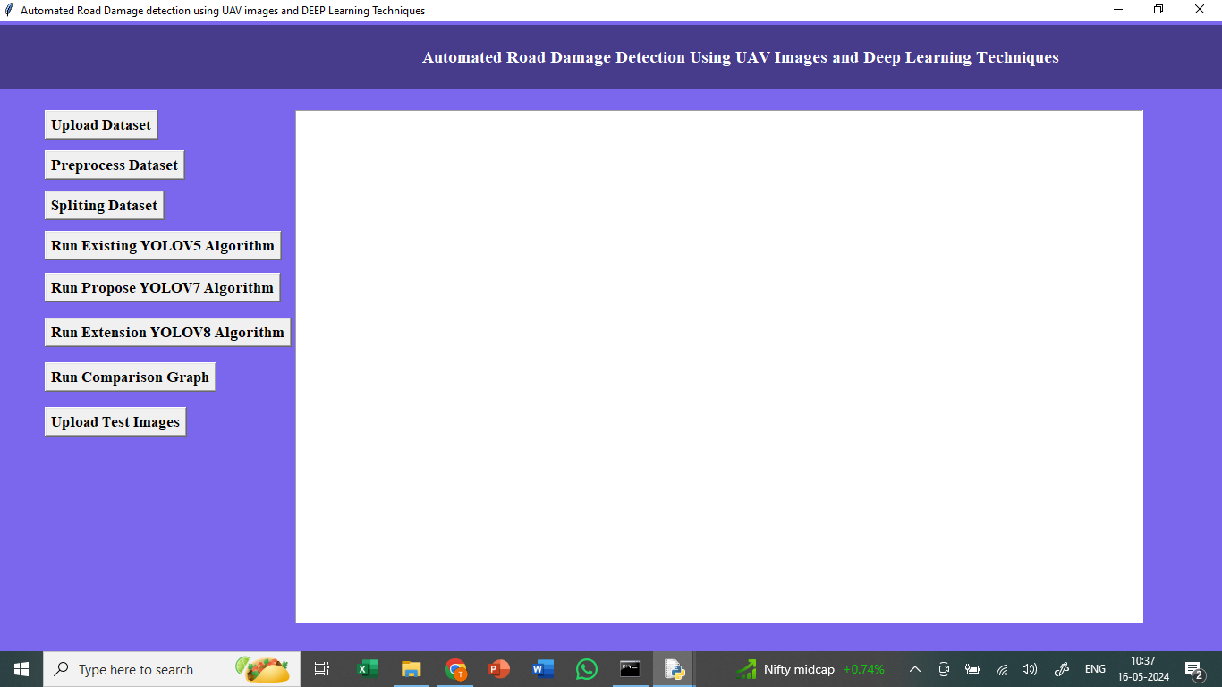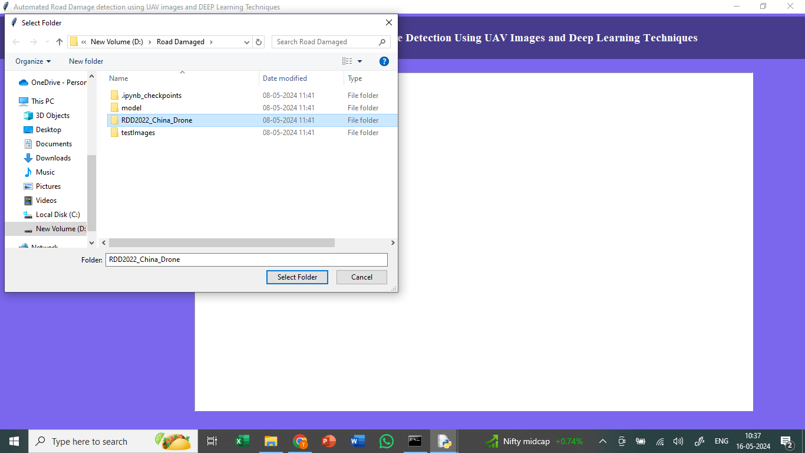
In above screen connecting and loading all dataset images and after executing above block will get below output

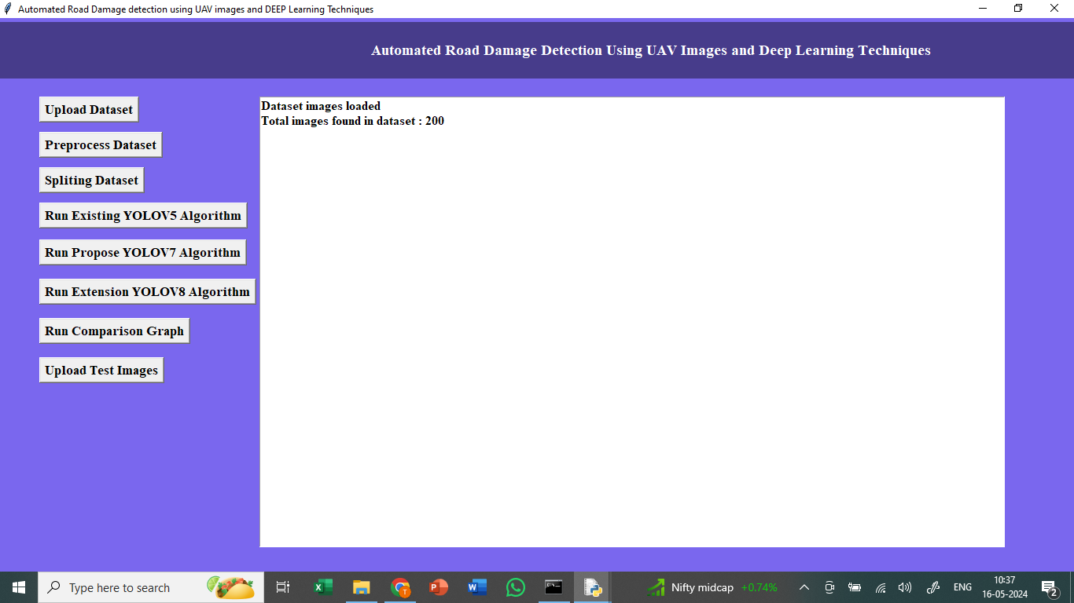
In above screen in text printing number of dataset images loaded
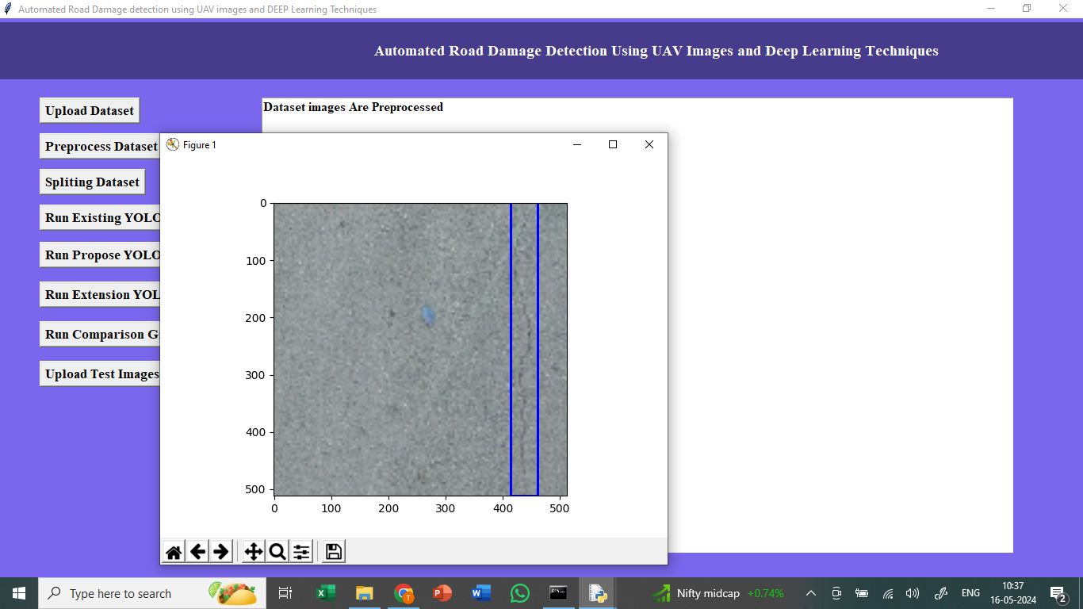
In above screen displaying one sample processed image with blue colour bounding box surrounded across damage road

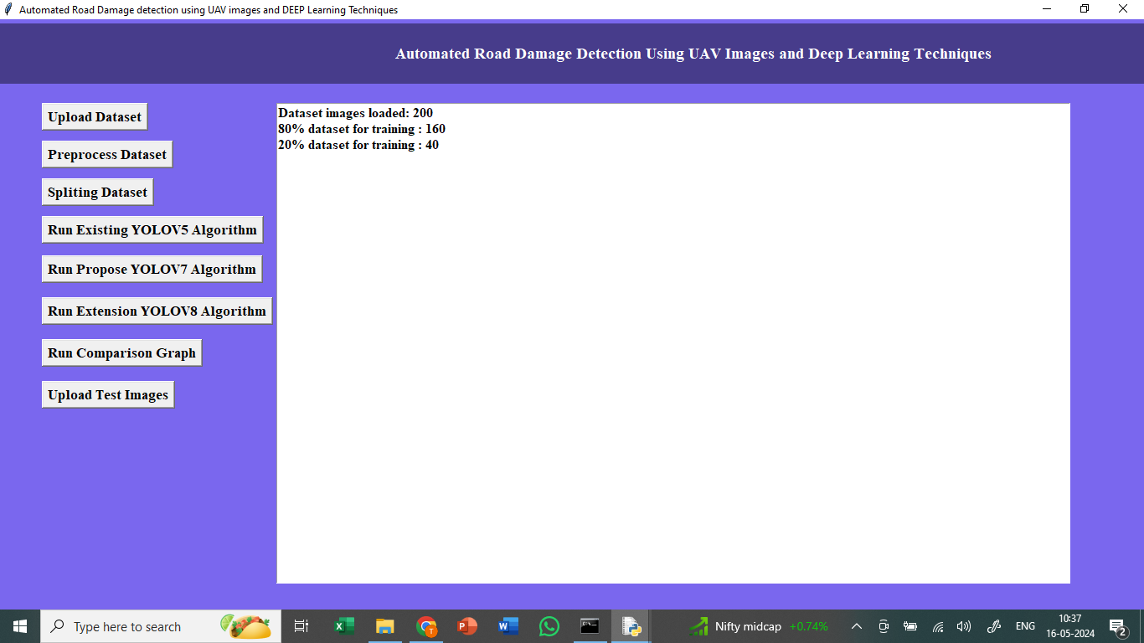
In above screen shuffling, normalizing and splitting dataset into train and test
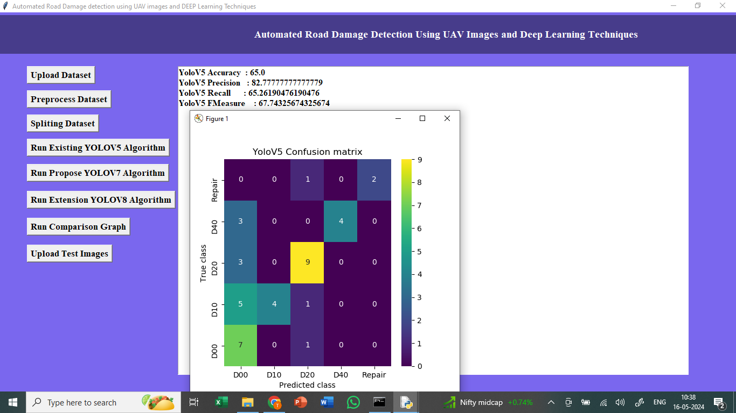
In above screen training Yolov5 model and YoloV5 got 65% accuracy and other metrics also displaying and in above confusion matrix x-axis represents Predicted Labels and y-axis represents True Labels and all boxes in diagnol represents correct prediction count and remaining boxes represents incorrect prediction count
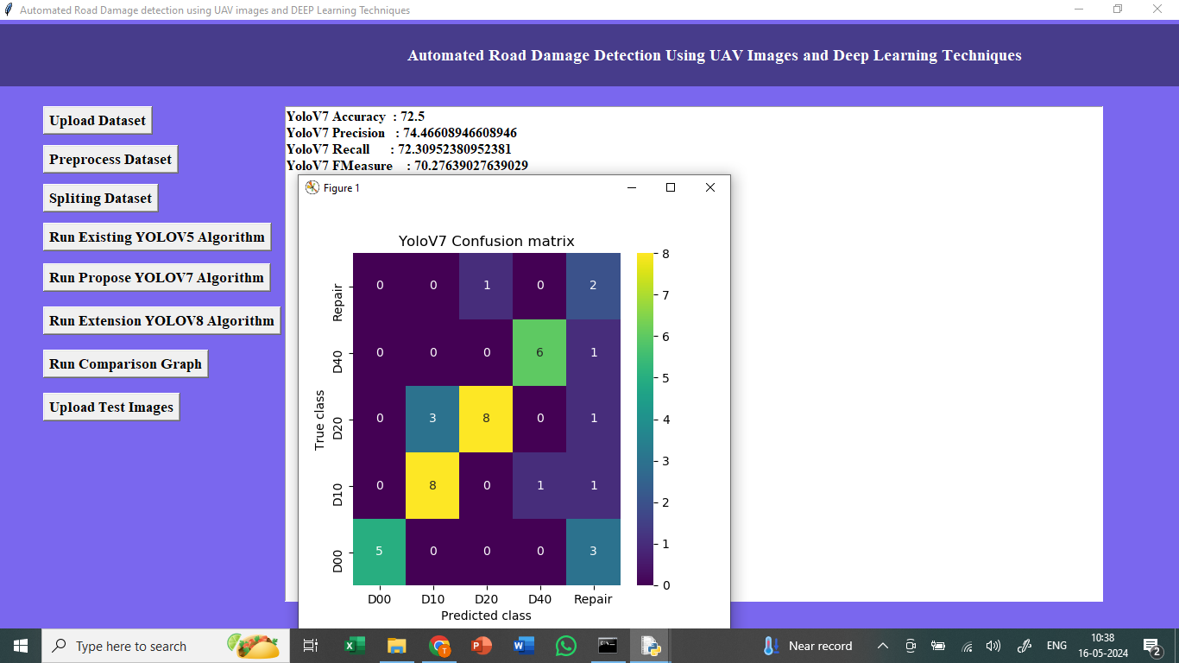
In above screen training Yolov7 and yolov7 got 82% accuracy and can see other metrics and confusion matrix graph

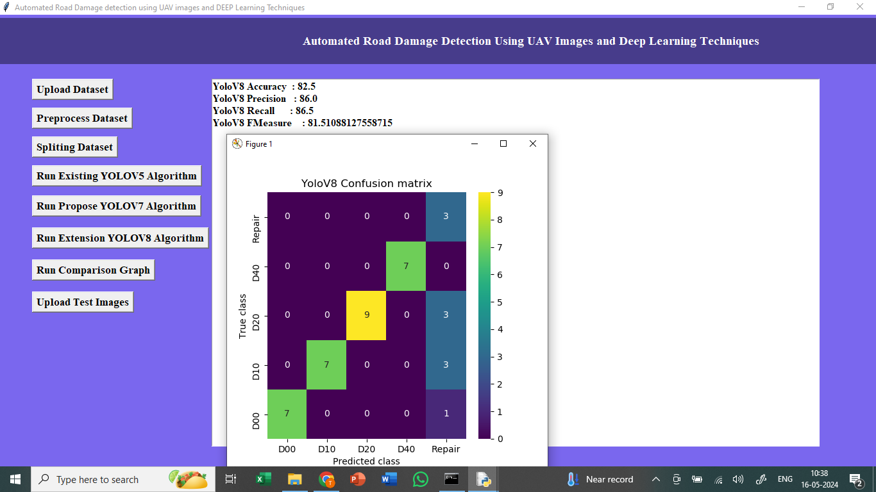
In above screen training Yolov8 from Ultralytics package and after executing above block YoloV8 got 85% accuracy which is higher than any other algorithm

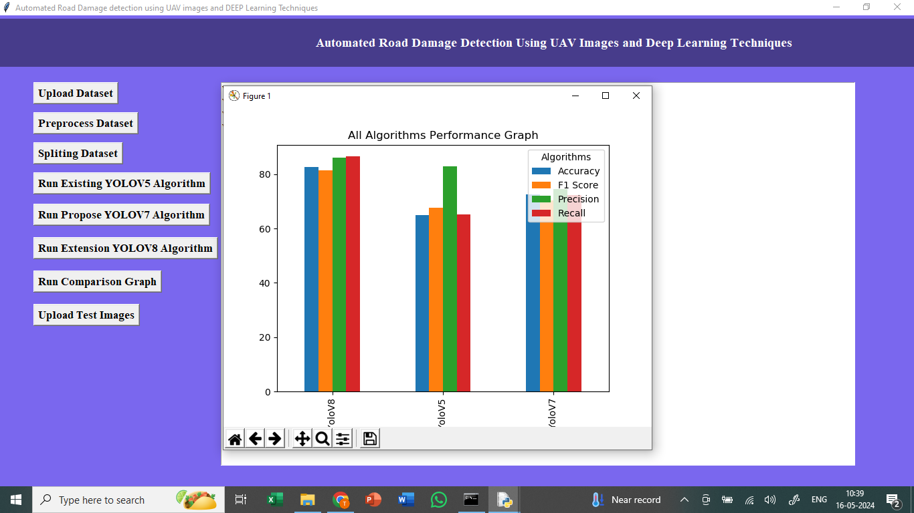
In above graph displaying comparison between all algorithms where x-axis represents algorithm names and y-axis represents accuracy and other metrics in different colour bars

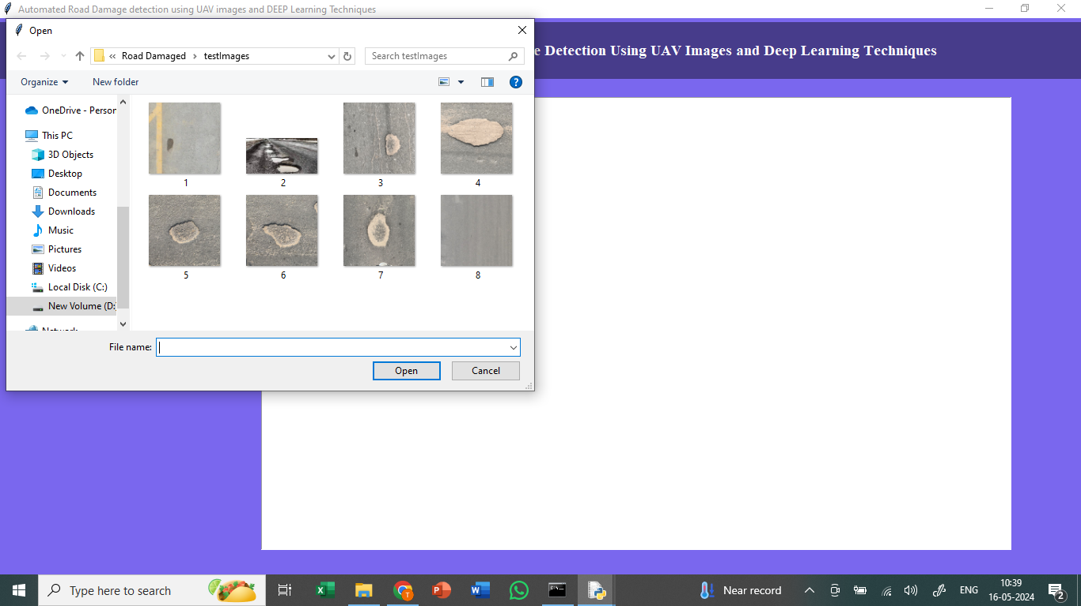
In above screen uploading road damaged image from test images folder
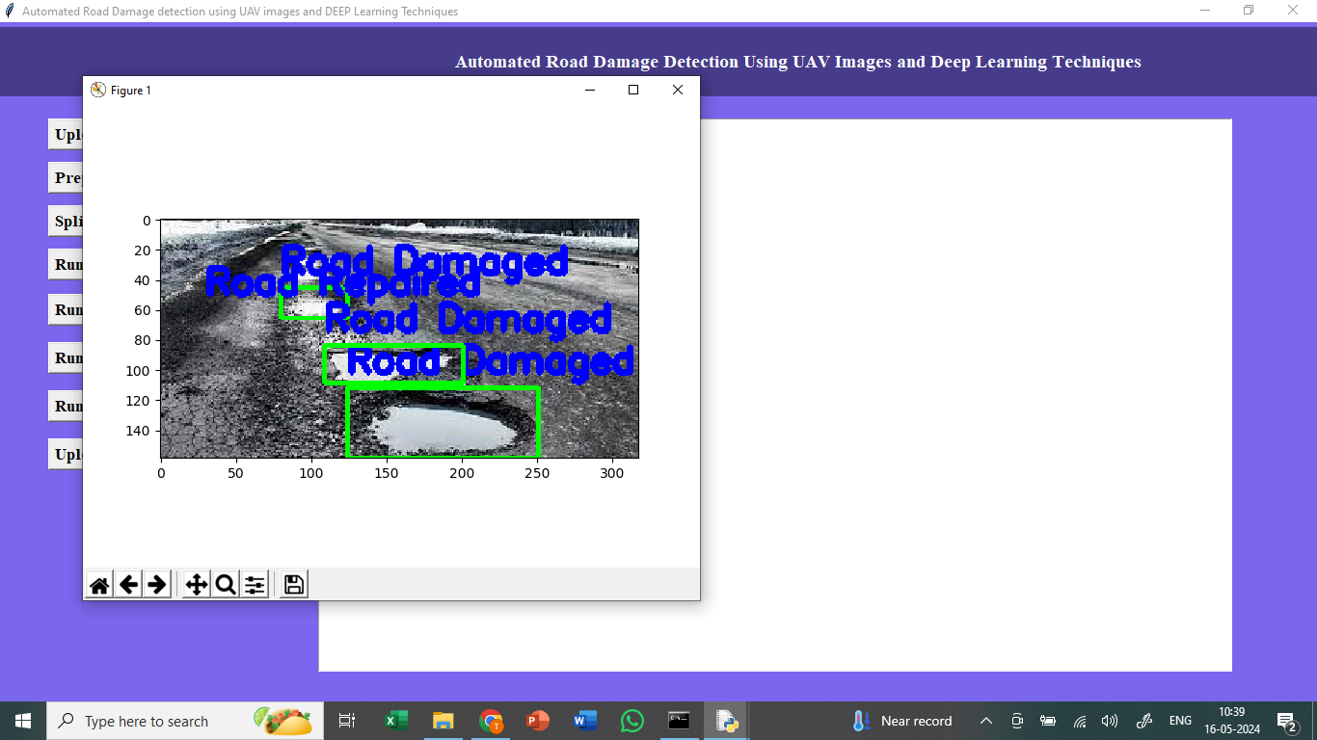
In above screen with bounding boxes damage road detected from given test input images

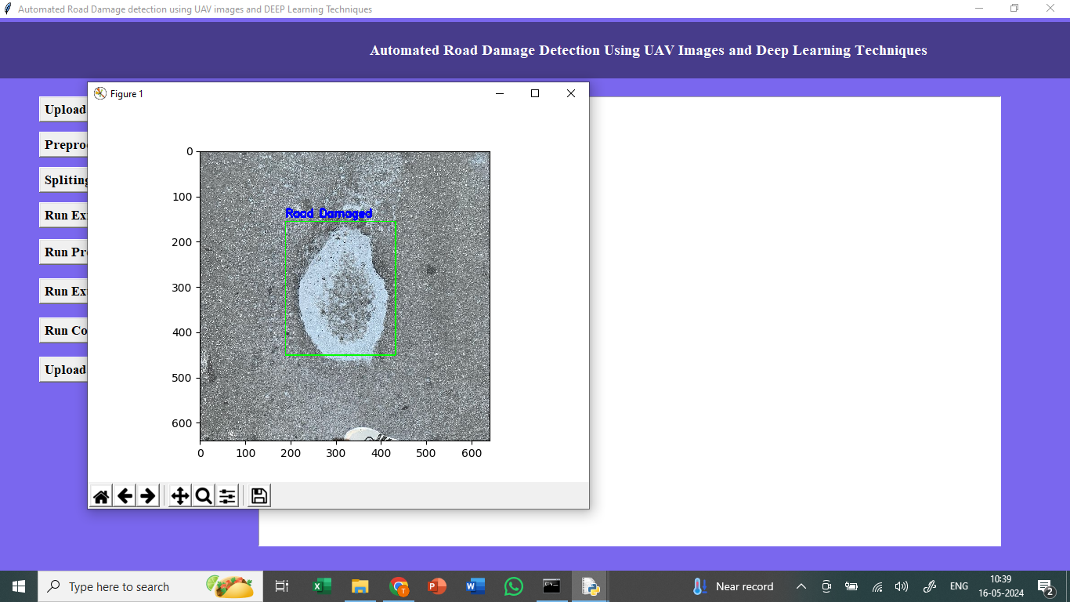
In above screen we can see other tested images

8. CONCLUSION:
In conclusion, this study compares the YOLOv4 from past work, the YOLOv5 and YOLOv7 architectures, and includes an implementation of the YOLOv5 with Transformer for road damage identification using UAV images. The research successfully achieved its goal of creating architecture capable of detecting road damage and demonstrated that new architecture versions, such as YOLOv5 and YOLOv7, can improve upon previous work. A significant contribution of this study was the development of a UAV image database tailored explicitly for training the YOLO versions, which was further enhanced by merging with the RDD2022 dataset. This improved detection of road damage samples, particularly for Spanish and Chinese roads, and helped reduce class imbalance for specific forms of road damage, such as potholes and alligator cracks. The findings of this study provide a valuable contribution to the field and pave the way for future research in this area. As presented in the results section, our implementation achieved a mAP.5 of 26.8% with YOLOv4, 59.9% with YOLOv5, and 73.20% with YOLOv7, finally the implemented Transformer achieved 65.7%. There is still scope for improvement in our work. Future research can explore the different types of images, such as multispectral images and LIDAR sensors, to further enhance the performance. The fusion of such information is potentially possible to yield better results using embedded computer. Moreover, another approach to this work is the use of fixed-wing UAV.
9. REFERENCES:
[1] H. S. S. Blas, A. C. Balea, A. S. Mendes, L. A. Silva, and G. V. González, ‘‘A platform for swimming pool detection and legal verification using a multi-agent system and remote image sensing,’’ Int. J. Interact. Multimedia Artif. Intell., vol. 2023, pp. 1–13, Jan. 2023.
[2] V. J. Hodge, R. Hawkins, and R. Alexander, ‘‘Deep reinforcement learning for drone navigation using sensor data,’’ Neural Comput. Appl., vol. 33, no. 6, pp. 2015–2033, Jun. 2020, doi: 10.1007/s00521-020-05097-x.
[3] A. Safonova, Y. Hamad, A. Alekhina, and D. Kaplun, ‘‘Detection of Norway spruce trees (Picea abies) infested by bark beetle in UAV images using YOLOs architectures,’’ IEEE Access, vol. 10, pp. 10384–10392, 2022.
[4] D. Gallacher, ‘‘Drones to manage the urban environment: Risks, rewards, alternatives,’’ J. Unmanned Vehicle Syst., vol. 4, no. 2, pp. 115–124, Jun. 2016.
[5] L. A. Silva, A. S. Mendes, H. S. S. Blas, L. C. Bastos, A. L. Gonçalves, and A. F. de Moraes, ‘‘Active actions in the extraction of urban objects for information quality and knowledge recommendation with machine learning,’’ Sensors, vol. 23, no. 1, p. 138, Dec. 2022, doi: 10.3390/ s23010138.
[6] L. Melendy, S. C. Hagen, F. B. Sullivan, T. R. H. Pearson, S. M. Walker, P. Ellis, A. K. Sambodo, O. Roswintiarti, M. A. Hanson, A. W. Klassen, M. W. Palace, B. H. Braswell, and G. M. Delgado, ‘‘Automated method for measuring the extent of selective logging damage with airborne LiDAR data,’’ ISPRS J. Photogramm. Remote Sens., vol. 139, pp. 228–240, May 2018, doi: 10.1016/j.isprsjprs.2018.02.022.
[7] L. A. Silva, H. S. S. Blas, D. P. García, A. S. Mendes, and G. V. González, ‘‘An architectural multi-agent system for a pavement monitoring system with pothole recognition in UAV images,’’ Sensors, vol. 20, no. 21, p. 6205, Oct. 2020, doi: 10.3390/s20216205.
[8] M. Guerrieri and G. Parla, ‘‘Flexible and stone pavements distress detection and measurement by deep learning and low-cost detection devices,’’ Eng. Failure Anal., vol. 141, Nov. 2022, Art. no. 106714, doi: 10.1016/j.engfailanal.2022.106714.
[9] D. Jeong, ‘‘Road damage detection using YOLO with smartphone images,’’ in Proc. IEEE Int. Conf. Big Data (Big Data), Dec. 2020, pp. 5559–5562, doi: 10.1109/BIGDATA50022.2020.9377847.
[10] M. Izadi, A. Mohammadzadeh, and A. Haghighattalab, ‘‘A new neuro-fuzzy approach for post-earthquake road damage assessment using GA and SVM classification from QuickBird satellite images,’’ J. Indian Soc. Remote Sens., vol. 45, no. 6, pp. 965–977, Mar. 2017.
[11] Y. Bhatia, R. Rai, V. Gupta, N. Aggarwal, and A. Akula, ‘‘Convolutional neural networks based potholes detection using thermal imaging,’’ J. King Saud Univ.-Comput. Inf. Sci., vol. 34, no. 3, pp. 578–588, Mar. 2022, doi: 10.1016/j.jksuci.2019.02.004.
[12] J. Guan, X. Yang, L. Ding, X. Cheng, V. C. Lee, and C. Jin, ‘‘Automated pixel-level pavement distress detection based on stereo vision and deep learning,’’ Automat. Constr., vol. 129, p. 103788, Sep. 2021, doi: 10.1016/j.autcon.2021.103788.
[13] D. Arya, H. Maeda, S. K. Ghosh, D. Toshniwal, and Y. Sekimoto, ‘‘RDD2022: A multi-national image dataset for automatic road damage detection,’’ 2022, arXiv:2209.08538.
[14] J. Redmon and A. Farhadi, ‘‘YOLO9000: Better, faster, stronger,’’ in Proc. IEEE Conf. Comput. Vis. Pattern Recognit. (CVPR), Honolulu, HI, USA, 2017, pp. 6517–6525, doi: 10.1109/CVPR.2017.690.
[15] J. Redmon and A. Farhadi. YOLOv3: An Incremental Improvement. [Online]. Available: https://pjreddie.com/yolo/
[16] A. Bochkovskiy, C.-Y. Wang, and H.-Y. Mark Liao, ‘‘YOLOv4: Optimal speed and accuracy of object detection,’’ 2020, arXiv:2004.10934.
[17] G. Jocher, A. Chaurasia, A. Stoken, J. Borovec, Y. Kwon, K. Michael, J. Fang, C. Wong, D. Montes, Z. Wang, C. Fati, J. Nadar, V. Sonck, P. Skalski, A. Hogan, D. Nair, M. Strobel, and M. Jain, ‘‘Ultralytics/YOLOv5: V7.0—YOLOv5 SOTA realtime instance segmentation,’’ Zenodo, Tech. Rep., Nov. 2022. [Online]. Available: https://zenodo.org/record/7347926
[18] C.-Y. Wang, A. Bochkovskiy, and H.-Y. Mark Liao, ‘‘YOLOv7: Trainable bag-of-freebies sets new state-of-the-art for real-time object detectors,’’ 2022, arXiv:2207.02696.
[19] R. Ali, D. Kang, G. Suh, and Y.-J. Cha, ‘‘Real-time multiple damage mapping using autonomous UAV and deep faster region-based neural networks for GPS-denied structures,’’ Autom. Construct., vol. 130, Oct. 2021, Art. no. 103831. [Online]. Available: https://www.sciencedirect.com/ science/article/pii/S092658052100282X
[20] D. Kang and Y.-J. Cha, ‘‘Autonomous UAVs for structural health monitoring using deep learning and an ultrasonic beacon system with geo-tagging: Autonomous UAVs for SHM,’’ Comput.-Aided Civil Infrastruct. Eng., vol. 33, no. 10, pp. 885–902, Oct. 2018.

